

A Sample Engagement Process for Implementing a Web Site

Develop Stage

Table of Contents
Business and Creative Workstream Overview 4
Content Workstream Overview 5
Organizational Readiness Workstream Overview 6
Technology Workstream Overview 7
Testing Workstream Overview 8
Develop Stage 9
Business and Creative Design Stage Overview 10
Content Stage Overview 11
Develop Publishing Workflows 12
Overview 12
Sample Work Product - INBOX.JSP 13
Develop Instant Publisher Forms 26
Overview 26
Sample Work Product - New_ip.jsp 27
Implement Third Party Tools in BroadVision Environment 41
Overview 41
Sample Work Product 42
Develop Data Model 43
Overview 43
Sample Work Product 44
Design Low-Level External Interface 45
Overview 45
Sample Work Product 46
Develop External Interface 47
Overview 47
Sample Work Product - Low Level External Interface Design -- Sample 48
Load and Tag Content 49
Overview 49
Sample Work Product 50
Develop Business Rules 51
Overview 51
Sample Work Product 52
Organizational Readiness Stage Overview 53
Technology Overview 54
Develop Web Pages 55
Overview 55
Sample Work Product - Web Page and Code Control Checklist 56
Sample Work Product - Web Page and Code Change Request Form 57
Sample Work Product - Issues and Opportunities for Improvement Template 59
Unit Test Web Pages 60
Overview 60
Sample Work Product - Test Strategy Template 61
Sample Work Product - Test Plan Template 63
Sample Work Product - Test Data Specification Template 64
Sample Work Product - Unit Test Plan 65
Sample Work Product - Unit Test Plan Example 66
Sample Work Product - Data Analysis Specifications 67
Sample Work Product - Additional Testing Information 69
Sample Work Product - Performance Test Plan 72
Sample Work Product - Perform Stress Test 73
Sample Work Product - Perform Stress Test 74
Develop Batch/Interface/Data Migration Programs 75
Overview 75
Sample Work Product - Data Migration Rules 77
Sample Work Product - Data Migration Timing and Automated Support 78
Sample Work Product - GUI Component Naming Conventions 79
Sample Work Product - Program Module Numbering Conventions 80
Sample Work Product - Error Identification and Cleansing Strategies 81
Sample Work Product - Action Diagram: Bracket Constructs 82
Sample Work Product - Action Diagram: Logic Control 83
Sample Work Product - Action Diagram: Data Accesses 84
Sample Work Product - Elementary Process Description Verbs 85
Sample Work Product - Program Logic Specification Verbs 85
Sample Work Product - Detail Logic Chart Verbs 87
Unit Test Batch/Interface/Data Migration Programs 88
Overview 88
Sample Work Product 89

Business and Creative Workstream Overview
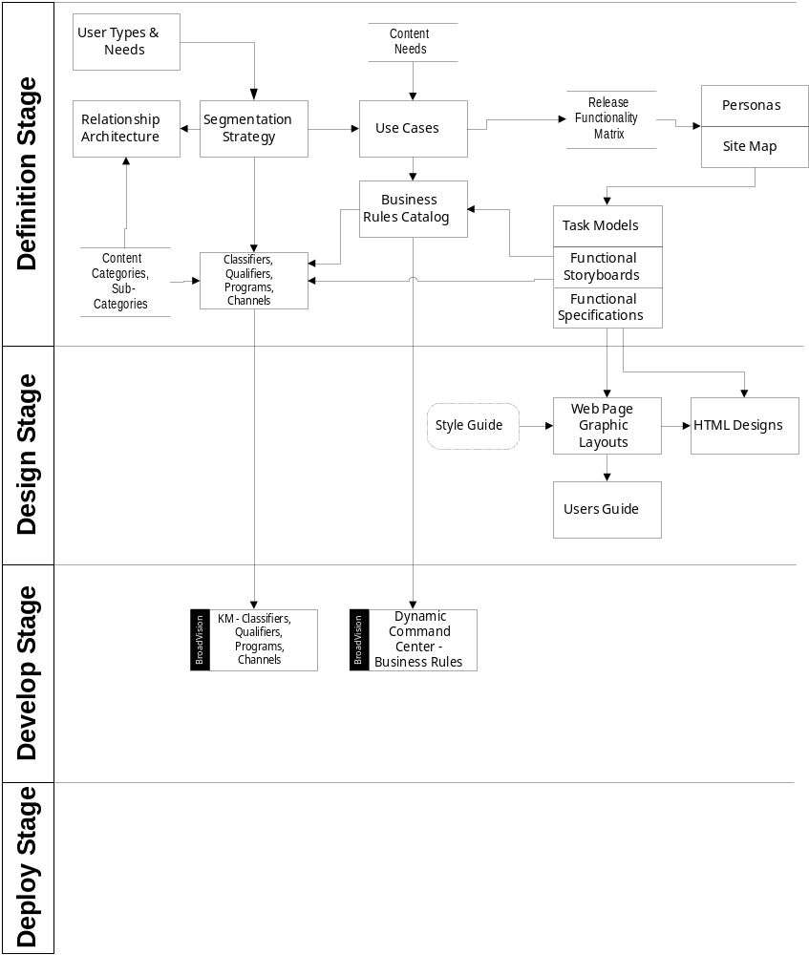

Content Workstream Overview
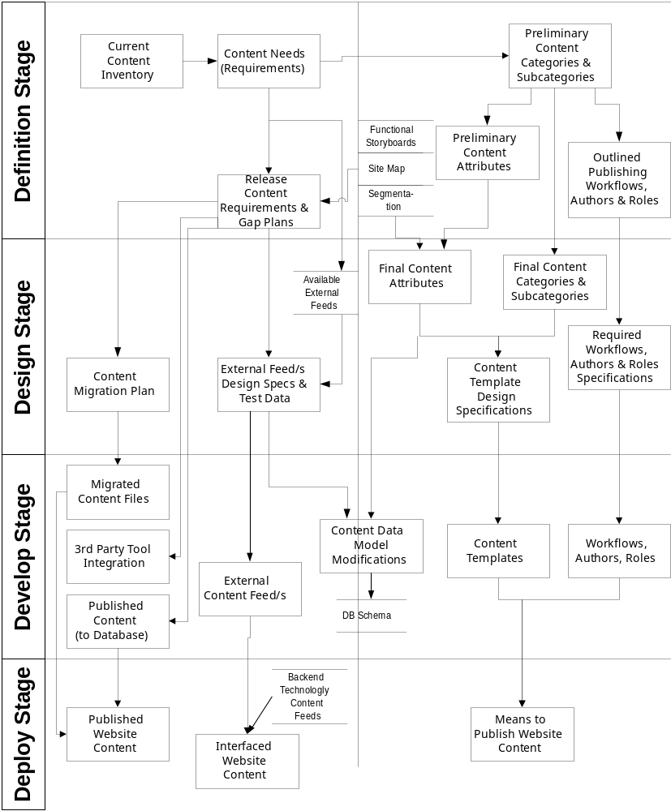

Organizational Readiness Workstream Overview
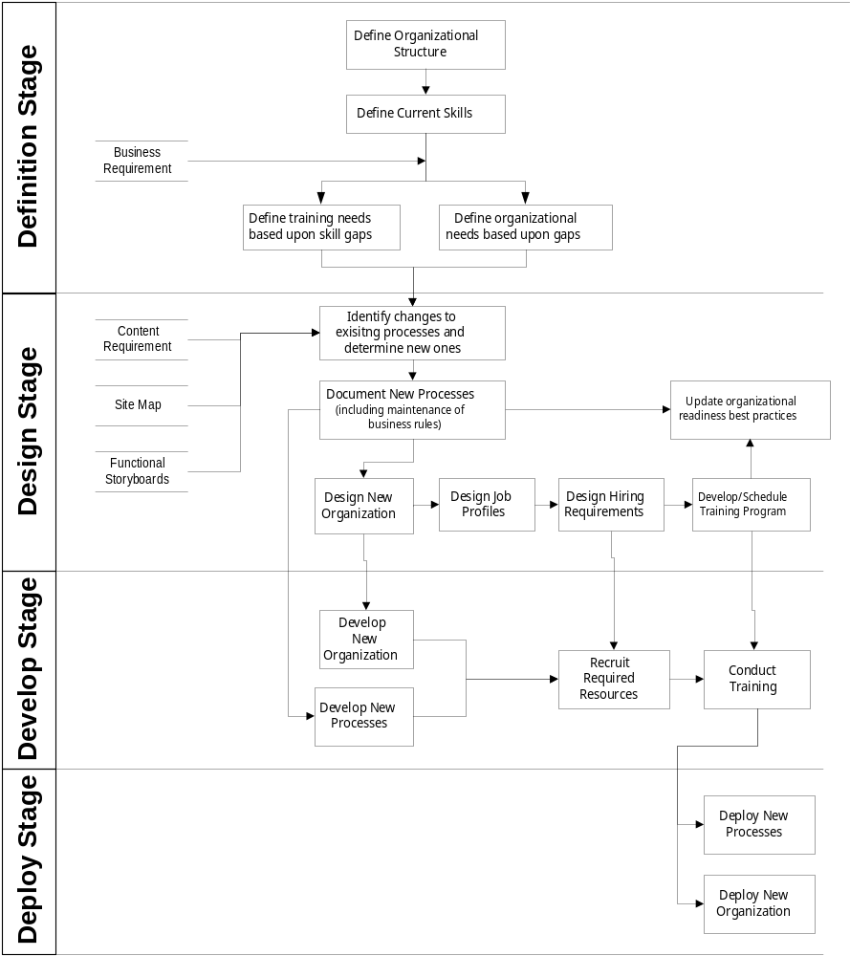

Technology Workstream Overview
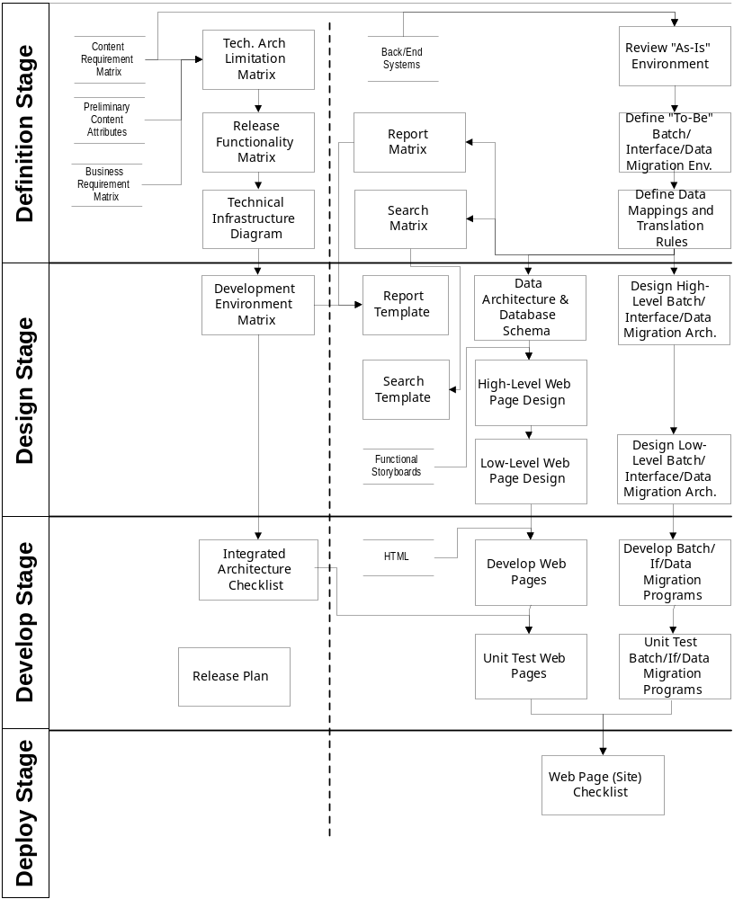

Testing Workstream Overview
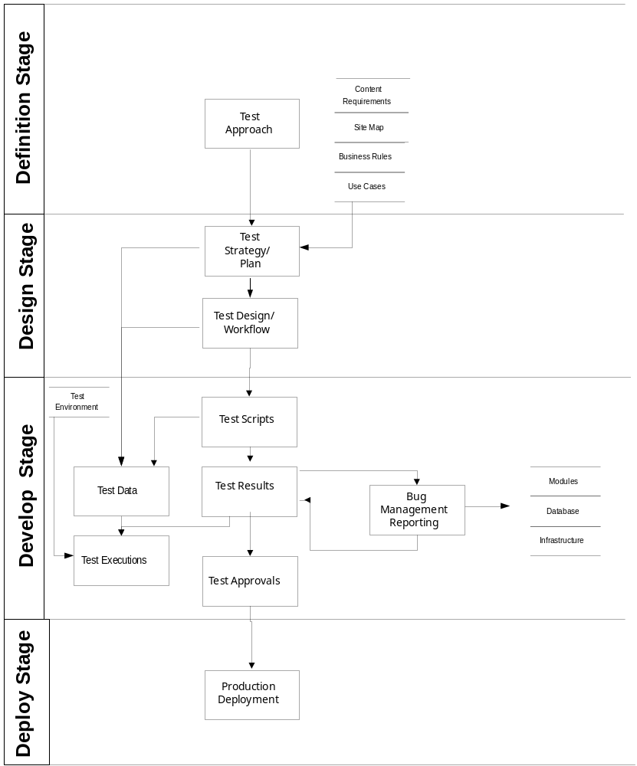

Develop Stage

1 - Business and Creative
A -
B -
C -

2 - Content
A - Develop Publishing Workflows
B - Develop Instant Publisher Forms
C - Implement Third Party Tools in BroadVision Environment
D - Develop Low-Level External I/F
E - Develop External I/F
F - Load and Tag Content
G - Develop Business Rules

3 - Organizational Readiness
A -
B -
C -
D -
E -
F -

4 - Technology
A - Develop Web Pages
B - Unit Test Web Pages
C - Develop Batch/Interface/Data Migration Programs
D - Unit Test Batch/Interface/Data Migration Programs

5 - Testing

Business and Creative Design Stage Overview

Content Stage Overview
Load and tag content
Develop business rules
Develop publishing workflows
Develop data model
Develop Instant Publisher forms
Implement third party tools in BVSN environment
Design Low-Level External I/F
Develop External I/F

Develop Publishing Workflows

Overview | Developing publishing workflows is the process of integrating the designed authors, roles and workflow into the Publishing Center so that site content can be created, tagged, approved and published by the appropriate authors within the BroadVision system.

Approach | The approach to developing publishing workflows is to build the process identified to create, tag and approve content within the organization into the Publishing Center. After the workflows are developed, the workflows are mapped to the Instant Publisher Forms which represent the appropriate corresponding categories of content (articles, products, etc...). Additionally, inboxes and access groups are created to correspond to the authors and roles identified in the design phase so that these individuals and/or groups of individuals can participate in the workflow process as designated in the design phase.

Work Product | The typical work product is the integration of all publishing workflows, authors and roles into the Publishing Center so that content can be published within the BroadVision system.

Input | Required inputs are the finalized design of authors, roles and workflows.

Sample Work Product - INBOX.JSP

<!-- Copyright(c) 2000 BroadVision, Inc. All Rights Reserved -->
<!DOCTYPE HTML PUBLIC '-//W3C//DTD HTML 4.0 Transitional//EN'>
<HTML>
<HEAD>
<TITLE>Inbox</TITLE>
<A NAME=topPage>
<link rel=stylesheet href='/style.css' type='text/css'>
<script src='/javascript/swapImage.js' language='JavaScript' type='text/javascript'></script>
<script src='/javascript/windows.js' language='JavaScript' type='text/javascript'></script>
<SCRIPT LANGUAGE='JavaScript'>
image_1610817380_on = new Image();
image_1610817380_on.src = "/images/main_Navigation/company_on.gif";
image_1610817380_off = new Image();
image_1610817380_off.src = "/images/main_Navigation/company_off.gif";

image_1610817077_on = new Image();
image_1610817077_on.src = "/images/main_Navigation/products_on.gif";
image_1610817077_off = new Image();
image_1610817077_off.src = "/images/main_Navigation/products_off.gif";

image_1610817078_on = new Image();
image_1610817078_on.src = "/images/main_Navigation/services_on.gif";
image_1610817078_off = new Image();
image_1610817078_off.src = "/images/main_Navigation/services_off.gif";

image_1610817079_on = new Image();
image_1610817079_on.src = "/images/main_Navigation/partners_on.gif";
image_1610817079_off = new Image();
image_1610817079_off.src = "/images/main_Navigation/partners_off.gif";

image_1610817080_on = new Image();
image_1610817080_on.src = "/images/main_Navigation/customers_on.gif";
image_1610817080_off = new Image();
image_1610817080_off.src = "/images/main_Navigation/customers_off.gif";

image_1610817084_on = new Image();
image_1610817084_on.src = "/images/main_Navigation/events_on.gif";
image_1610817084_off = new Image();
image_1610817084_off.src = "/images/main_Navigation/events_off.gif";

image_1610817082_on = new Image();
image_1610817082_on.src = "/images/main_Navigation/training_on.gif";
image_1610817082_off = new Image();
image_1610817082_off.src = "/images/main_Navigation/training_off.gif";

image_1610817083_on = new Image();
image_1610817083_on.src = "/images/main_Navigation/careers_on.gif";
image_1610817083_off = new Image();
image_1610817083_off.src = "/images/main_Navigation/careers_off.gif";

image_1610817081_on = new Image();
image_1610817081_on.src = "/images/main_Navigation/news_on.gif";
image_1610817081_off = new Image();
image_1610817081_off.src = "/images/main_Navigation/news_off.gif";

image_1610817436_on = new Image();
image_1610817436_on.src = "/images/main_Navigation/publish_on.gif";
image_1610817436_off = new Image();
image_1610817436_off.src = "/images/main_Navigation/publish_off.gif";

image_1610817294_on = new Image();
image_1610817294_on.src = "/images/homeNavigation/home_on.gif";
image_1610817294_off = new Image();
image_1610817294_off.src = "/images/homeNavigation/home_off.gif";

image_1610817085_on = new Image();
image_1610817085_on.src = "/images/homeNavigation/logout_on.gif";
image_1610817085_off = new Image();
image_1610817085_off.src = "/images/homeNavigation/logout_off.gif";

image_1610817202_on = new Image();
image_1610817202_on.src = "/images/homeNavigation/profile_on.gif";
image_1610817202_off = new Image();
image_1610817202_off.src = "/images/homeNavigation/profile_off.gif";

</SCRIPT>
</HEAD>
<BODY BGCOLOR='#FFFFFF' VLINK='#990099'>
<TABLE BORDER=0 CELLPADDING=0 CELLSPACING=0 WIDTH=700>
<TR>
<!-- Top Header -->
<TD><TABLE BORDER=0 BGCOLOR='#333399' CELLPADDING=0 CELLSPACING=0 WIDTH=700>
<TR><TD><TABLE BORDER=0 BGCOLOR='#333399' CELLPADDING=0 CELLSPACING=0 WIDTH=700>
<TR><!-- BroadVision Logo -->
<TD WIDTH=169 HEIGHT=56 ALIGN='center' hspace=7 VALIGN='Top'>
<A HREF=/OneToOne/SessionMgr/extranet/extranet_home.jsp?BV_SessionID=NNNN1314359520.0969331114NNNN&BV_EngineID=ealileljhldbfdmckgcfhhclf.0&channelName=NA&channelRuleset=NA&programName=Home&programRuleset=NA ><IMG SRC=/images/bvlogo_333399.gif WIDTH=169 HEIGHT=38 BORDER=0 ALT='BroadVision'></A></TD>
<TD WIDTH=380 HEIGHT=56 ALIGN='left' VALIGN='top'>
<!-- Quote -->
<TABLE BORDER=0 CELLPADDING=0 CELLSPACING=0 WIDTH=530>
</tr><td ><IMG SRC="/images/small_121.gif"HEIGHT="80"WIDTH="61"><IMG SRC=/images/blank.gif height=10 width=1></td><TD><table CELLPADDING=0 CELLSPACING=0 width=><TR><TD ALIGN="left"><SPAN CLASS=pageQuoteText><BR>"BroadVision's one-to-one capabilities fit closely with our high level of customer service. Now, Azlan can leverage our strength in customer loyalty while increasing the number of services we offer over the Internet." </SPAN></TD></TR>
<TR><TD ALIGN="right"><SPAN CLASS=pageQuotePerson>Richard Abbott, Group IT Service Manager, Azlan Group, Plc</SPAN></TD></TR></table></TD></tr></TABLE></TD>
</TR></TABLE>
<!-- End Quote -->
</TD>
</TR>
<TR><TD>
<TABLE BORDER=0 CELLPADDING=0 CELLSPACING=0 WIDTH=700>
<TR><TD WIDTH=150 ALIGN='left' BGCOLOR='#666666'>
<TABLE BORDER=0 CELLPADDING=0 CELLSPACING=0><TR BGCOLOR=#666666>
<TD ALIGN="left" BGCOLOR=#666666><A HREF=/OneToOne/SessionMgr/extranet/extranet_home.jsp?BV_SessionID=NNNN1314359520.0969331114NNNN&BV_EngineID=ealileljhldbfdmckgcfhhclf.0&channelName=NA&channelRuleset=NA&programName=Home&programRuleset=NA onMouseOut="swapImageOff('image_1610817294')" onMouseOver="swapImageOn('image_1610817294')" onMouseUp="swapImageOff('image_1610817294')" onMouseDown="swapImageOn('image_1610817294')"><IMG NAME="image_1610817294" SRC="/images/homeNavigation/home_off.gif" WIDTH=46 HEIGHT=19 BORDER=0 ALT="Extranet Home"></A></TD><TD ALIGN="left" BGCOLOR=#666666><A HREF=/OneToOne/SessionMgr/logout.jsp?BV_SessionID=NNNN1314359520.0969331114NNNN&BV_EngineID=ealileljhldbfdmckgcfhhclf.0&channelName=NA&channelRuleset=NA&programName=Logout&programRuleset=NA onMouseOut="swapImageOff('image_1610817085')" onMouseOver="swapImageOn('image_1610817085')" onMouseUp="swapImageOff('image_1610817085')" onMouseDown="swapImageOn('image_1610817085')"><IMG NAME="image_1610817085" SRC="/images/homeNavigation/logout_off.gif" WIDTH=47 HEIGHT=19 BORDER=0 ALT="Logout"></A></TD><TD ALIGN="left" BGCOLOR=#666666><A HREF=/OneToOne/SessionMgr/profile/profile.jsp?BV_SessionID=NNNN1314359520.0969331114NNNN&BV_EngineID=ealileljhldbfdmckgcfhhclf.0&channelName=My+Profile&channelRuleset=Profile+Channels&programName=My+Profile&programRuleset=NA onMouseOut="swapImageOff('image_1610817202')" onMouseOver="swapImageOn('image_1610817202')" onMouseUp="swapImageOff('image_1610817202')" onMouseDown="swapImageOn('image_1610817202')"><IMG NAME="image_1610817202" SRC="/images/homeNavigation/profile_off.gif" WIDTH=53 HEIGHT=19 BORDER=0 ALT="Profile"></A></TD></TR><tr><td colspan=3><TABLE BORDER=0 CELLPADDING=0 CELLSPACING=0 width=100%>
<TR><TD ALIGN=left><A HREF=/OneToOne/SessionMgr/pub_dm/inbox.jsp?BV_SessionID=NNNN1314359520.0969331114NNNN&BV_EngineID=ealileljhldbfdmckgcfhhclf.0&channelName=Inbox&channelRuleset=Instant+Publishers+Channels&programName=Inbox&programRuleset=NA ><IMG NAME="image_1610817436" SRC="/images/main_Navigation/publish_on.gif" WIDTH=60 HEIGHT=19 BORDER=0 ALT="Instant Publishers"></A></TD><TD ALIGN=right ><IMG height=19 width=45 alt="blank" src="/images/tools_blank.gif" ></TD><TD ALIGN=right ><IMG height=19 width=41 alt="blank" src="/images/curve.gif" ></TD> </TR></TABLE></td></tr></TABLE> </TD>
<!-- Top Main Navigation -->
<TD WIDTH=550 BGCOLOR=#FFFFFF>
<TABLE BORDER=0 CELLPADDING=0 CELLSPACING=0 WIDTH=100% BGCOLOR=#6666cc >
<TR><TD ALIGN="left"><A HREF=/OneToOne/SessionMgr/company/factsheet.jsp?BV_SessionID=NNNN1314359520.0969331114NNNN&BV_EngineID=ealileljhldbfdmckgcfhhclf.0&channelName=BroadVision+At-A-Glance&channelRuleset=Company+Channels&programName=BroadVision+At-A-Glance&programRuleset=NA onMouseOut="swapImageOff('image_1610817380')" onMouseOver="swapImageOn('image_1610817380')" onMouseUp="swapImageOff('image_1610817380')" onMouseDown="swapImageOn('image_1610817380')"><IMG NAME="image_1610817380" SRC="/images/main_Navigation/company_off.gif" WIDTH=71 HEIGHT=19 BORDER=0 ALT="Company"></A></TD><TD ALIGN="left"><A HREF=/OneToOne/SessionMgr/products/overview.jsp?BV_SessionID=NNNN1314359520.0969331114NNNN&BV_EngineID=ealileljhldbfdmckgcfhhclf.0&channelName=Overview&channelRuleset=Products+Channels&programName=Overview&programRuleset=NA onMouseOut="swapImageOff('image_1610817077')" onMouseOver="swapImageOn('image_1610817077')" onMouseUp="swapImageOff('image_1610817077')" onMouseDown="swapImageOn('image_1610817077')"><IMG NAME="image_1610817077" SRC="/images/main_Navigation/products_off.gif" WIDTH=64 HEIGHT=19 BORDER=0 ALT="Products"></A></TD><TD ALIGN="left"><A HREF=/OneToOne/SessionMgr/services/services.jsp?BV_SessionID=NNNN1314359520.0969331114NNNN&BV_EngineID=ealileljhldbfdmckgcfhhclf.0&channelName=Overview&channelRuleset=Services+Channels&programName=Overview&programRuleset=NA onMouseOut="swapImageOff('image_1610817078')" onMouseOver="swapImageOn('image_1610817078')" onMouseUp="swapImageOff('image_1610817078')" onMouseDown="swapImageOn('image_1610817078')"><IMG NAME="image_1610817078" SRC="/images/main_Navigation/services_off.gif" WIDTH=58 HEIGHT=19 BORDER=0 ALT="Services"></A></TD><TD ALIGN="left"><A HREF=/OneToOne/SessionMgr/partners/partners_listing.jsp?BV_SessionID=NNNN1314359520.0969331114NNNN&BV_EngineID=ealileljhldbfdmckgcfhhclf.0&partnerType=All&channelName=Partner+List&channelRuleset=Partners+Channels&programName=All+Partners&programRuleset=Partner+List+Programs onMouseOut="swapImageOff('image_1610817079')" onMouseOver="swapImageOn('image_1610817079')" onMouseUp="swapImageOff('image_1610817079')" onMouseDown="swapImageOn('image_1610817079')"><IMG NAME="image_1610817079" SRC="/images/main_Navigation/partners_off.gif" WIDTH=62 HEIGHT=19 BORDER=0 ALT="Partners"></A></TD><TD ALIGN="left"><A HREF=/OneToOne/SessionMgr/customers/customer_list.jsp?BV_SessionID=NNNN1314359520.0969331114NNNN&BV_EngineID=ealileljhldbfdmckgcfhhclf.0&Industry=All&customerType=All&channelName=Customer+List&channelRuleset=Customers+Channels&programName=All+Customers&programRuleset=Customer+List+Programs onMouseOut="swapImageOff('image_1610817080')" onMouseOver="swapImageOn('image_1610817080')" onMouseUp="swapImageOff('image_1610817080')" onMouseDown="swapImageOn('image_1610817080')"><IMG NAME="image_1610817080" SRC="/images/main_Navigation/customers_off.gif" WIDTH=72 HEIGHT=19 BORDER=0 ALT="Customers"></A></TD><TD ALIGN="left"><A HREF=/OneToOne/SessionMgr/events/events.jsp?BV_SessionID=NNNN1314359520.0969331114NNNN&BV_EngineID=ealileljhldbfdmckgcfhhclf.0&Industry=All&channelName=Events+List&channelRuleset=Events+Channels&programName=All+Events&programRuleset=Events+List+Programs onMouseOut="swapImageOff('image_1610817084')" onMouseOver="swapImageOn('image_1610817084')" onMouseUp="swapImageOff('image_1610817084')" onMouseDown="swapImageOn('image_1610817084')"><IMG NAME="image_1610817084" SRC="/images/main_Navigation/events_off.gif" WIDTH=49 HEIGHT=19 BORDER=0 ALT="Events"></A></TD><TD ALIGN="left"><A HREF="http://www.bvuniversity.com" TARGET="BVU" onMouseOut="swapImageOff('image_1610817082')" onMouseOver="swapImageOn('image_1610817082')" onMouseUp="swapImageOff('image_1610817082')" onMouseDown="swapImageOn('image_1610817082')"><IMG NAME="image_1610817082" SRC="/images/main_Navigation/training_off.gif" WIDTH=62 HEIGHT=19 BORDER=0 ALT="Training"></A></TD><TD ALIGN="left"><A HREF=/OneToOne/SessionMgr/careers/career_info.jsp?BV_SessionID=NNNN1314359520.0969331114NNNN&BV_EngineID=ealileljhldbfdmckgcfhhclf.0&mode=Introduction&channelName=Working+at+Broadvision&channelRuleset=Careers+Channels&programName=Introduction&programRuleset=Working+at+Broadvision+Programs onMouseOut="swapImageOff('image_1610817083')" onMouseOver="swapImageOn('image_1610817083')" onMouseUp="swapImageOff('image_1610817083')" onMouseDown="swapImageOn('image_1610817083')"><IMG NAME="image_1610817083" SRC="/images/main_Navigation/careers_off.gif" WIDTH=55 HEIGHT=19 BORDER=0 ALT="Careers"></A></TD><TD ALIGN="left"><A HREF=/OneToOne/SessionMgr/news/news_listing.jsp?BV_SessionID=NNNN1314359520.0969331114NNNN&BV_EngineID=ealileljhldbfdmckgcfhhclf.0&newsType=All&channelName=Press+Releases&channelRuleset=News+Channels&programName=All+News&programRuleset=Press+Releases+Programs onMouseOut="swapImageOff('image_1610817081')" onMouseOver="swapImageOn('image_1610817081')" onMouseUp="swapImageOff('image_1610817081')" onMouseDown="swapImageOn('image_1610817081')"><IMG NAME="image_1610817081" SRC="/images/main_Navigation/news_off.gif" WIDTH=42 HEIGHT=19 BORDER=0 ALT="News"></A></TD> <TD BGCOLOR=#6666cc><IMG SRC=/images/main_Navigation/top_nav_spacer.gif WIDTH=19 HEIGHT=1></TD></TR></TABLE> </TD>
</TR></TABLE>
</TD></TR>
</TABLE></TD>
</TR>
<!-- End of Top Header -->
<TR><TD HEIGHT=16 ALIGN='left'>&nbsp;</TD></TR>
<TR><TD>
<TABLE BORDER=0 CELLPADDING=0 CELLSPACING=0 WIDTH=700>
<TR>
<TD WIDTH=140 ALIGN='left'>
<!-- Search Area -->
<TABLE BORDER=0 CELLPADDING=2 CELLSPACING=0 WIDTH=140>
<TR><TD><FORM METHOD=POST NAME=searchForm ACTION='/OneToOne/SessionMgr/search/search_results.jsp'>
<input type=hidden name="BV_SessionID" value="NNNN1314359520.0969331114NNNN">
<input type=hidden name="BV_EngineID" value="ealileljhldbfdmckgcfhhclf.0">
<INPUT TYPE=text NAME='queryString' SIZE=9 MAXLENGTH=50></TD>
<TD>
<INPUT TYPE='image' SRC='/images/buttons/search.gif' ALT='Search' VSPACE='2' BORDER='0'>
<INPUT TYPE=hidden NAME='maxItems' VALUE=200>
<INPUT TYPE=hidden NAME='sortOrder' VALUE='desc'>
<INPUT TYPE=hidden NAME='sortField' VALUE='Score'>
<INPUT TYPE=hidden NAME='collectionName' VALUE='GrandSite_Search_Public'>
<INPUT TYPE=hidden NAME='curStart' VALUE=0>
<INPUT TYPE=hidden NAME='curEnd' VALUE=10>
</FORM></TD>
</TR></TABLE>
<!-- End of Search Area -->
</TD>
<!-- Vertical Gutter -->
<TD WIDTH=10 ALIGN='left'>&nbsp;</TD>
<!-- Page Header -->
<TD ALIGN='left'>
<TABLE BORDER=0 CELLPADDING=3 CELLSPACING=0 WIDTH=500>
<TR><TD ALIGN=left>
<A HREF=/OneToOne/SessionMgr/pub_dm/inbox.jsp?BV_SessionID=NNNN1314359520.0969331114NNNN&BV_EngineID=ealileljhldbfdmckgcfhhclf.0&channelName=Inbox&channelRuleset=Instant+Publishers+Channels&programName=Inbox&programRuleset=NA CLASS="breadcrumbLink">Instant Publishers</A>
</TD></TR>
<TR><TD ALIGN=left><SPAN CLASS=programNameText>Inbox</SPAN></TD></TR></TABLE>
</TD>
<TD WIDTH=40 ROWSPAN=3 ALIGN='left'><IMG SRC=/images/blank.gif WIDTH=40></TD>
</TR>
<!-- End of Page Header -->
<!-- Horizontal Gutter -->
<TR><TD COLSPAN=3 HEIGHT=20 ALIGN=left>&nbsp;</TD></TR>
<!-- Left Navigation -->
<TD WIDTH=140 ALIGN='left' VALIGN=top>
<TABLE BORDER=0 CELLPADDING=3 CELLSPACING=0> <TR VALIGN=top><TD WIDTH=10 ALIGN=right><IMG SRC="/images/bullets/hyphen_pink.gif" WIDTH=9 HEIGHT=8 BORDER=0></TD>
<TD WIDTH=130 ALIGN=left><A HREF=/OneToOne/SessionMgr/pub_dm/inbox.jsp?BV_SessionID=NNNN1314359520.0969331114NNNN&BV_EngineID=ealileljhldbfdmckgcfhhclf.0&channelName=Inbox&channelRuleset=Instant+Publishers+Channels&programName=Inbox&programRuleset=NA CLASS="activeLeftNavLink">INBOX</A><BR>&nbsp;</TD></TR>
<TR VALIGN=top><TD WIDTH=10 ALIGN=right><IMG SRC="/images/bullets/hyphen_blue.gif" WIDTH=9 HEIGHT=8 BORDER=0></TD>
<TD WIDTH=130 ALIGN=left><A HREF=/OneToOne/SessionMgr/pub_dm/news_ip.jsp?BV_SessionID=NNNN1314359520.0969331114NNNN&BV_EngineID=ealileljhldbfdmckgcfhhclf.0&channelName=Press+Releases&channelRuleset=Instant+Publishers+Channels&programName=Press+Releases&programRuleset=NA CLASS="inActiveLeftNavLink">PRESS RELEASES</A><BR>&nbsp;</TD></TR>
<TR VALIGN=top><TD WIDTH=10 ALIGN=right><IMG SRC="/images/bullets/hyphen_blue.gif" WIDTH=9 HEIGHT=8 BORDER=0></TD>
<TD WIDTH=130 ALIGN=left><A HREF=/OneToOne/SessionMgr/pub_dm/news_ip.jsp?BV_SessionID=NNNN1314359520.0969331114NNNN&BV_EngineID=ealileljhldbfdmckgcfhhclf.0&channelName=Corporate+Events&channelRuleset=Instant+Publishers+Channels&programName=Corporate+Events&programRuleset=NA CLASS="inActiveLeftNavLink">CORPORATE EVENTS</A><BR>&nbsp;</TD></TR>
<TR VALIGN=top><TD WIDTH=10 ALIGN=right><IMG SRC="/images/bullets/hyphen_blue.gif" WIDTH=9 HEIGHT=8 BORDER=0></TD>
<TD WIDTH=130 ALIGN=left><A TARGET=_blank HREF=/OneToOne/SessionMgr/admin/login_as.jsp?dummy=dummy&UsErNaMe=editor&submit_action=Get%2bUser&channelName=Editor+View&channelRuleset=Instant+Publishers+Channels&programName=Editor+View&programRuleset=NA CLASS="inActiveLeftNavLink">EDITOR VIEW</A><BR>&nbsp;</TD></TR>
</TABLE>
</TD>
<!-- End of Left Navigation -->
<!-- Vertical Gutter -->
<TD WIDTH=10 ALIGN='left'>&nbsp;</TD>
<!-- Body -->
<TD ALIGN='left'>
<TABLE WIDTH="100%" BORDER=0 CELLPADDING="0" CELLSPACING="0">
<TR BGCOLOR="#99ccff">
<TD WIDTH=30%><FONT FACE="Arial, Helvetica, sans-serif" SIZE=-2>&nbsp;FROM</FONT></TD>
<TD WIDTH=55%><FONT FACE="Arial, Helvetica, sans-serif" SIZE=-2>SUBJECT</FONT></TD>
<TD WIDTH=15%><FONT FACE="Arial, Helvetica, sans-serif" SIZE=-2>RECEIVED</FONT></TD>
<TD WIDTH=7%><FONT FACE="Arial, Helvetica, sans-serif" SIZE=-2>STATUS</FONT></TD>
<TR>
<TD><SPAN CLASS=defaultFont>Editor </SPAN></TD>
<TD><SPAN CLASS=defaultFont><A HREF=/OneToOne/SessionMgr/pub_dm/news_ip.jsp?BV_SessionID=NNNN1314359520.0969331114NNNN&BV_EngineID=ealileljhldbfdmckgcfhhclf.0&contentOID=537077500&last_mod_time=17:30:01><font color=purple><b><i>Moo, moo,

moo...</font></b></i></A></SPAN></TD>
<TD ALIGN=center NOWRAP><SPAN CLASS=defaultFont>09/18/00 17:30:01</SPAN>&nbsp; </TD>
<TD NOWRAP><SPAN CLASS=defaultFont>On-line</SPAN></TD>
</TR>
<TR>
<TD><SPAN CLASS=defaultFont>Editor </SPAN></TD>
<TD><SPAN CLASS=defaultFont><A HREF=/OneToOne/SessionMgr/pub_dm/news_ip.jsp?BV_SessionID=NNNN1314359520.0969331114NNNN&BV_EngineID=ealileljhldbfdmckgcfhhclf.0&contentOID=537077501&last_mod_time=17:30:01>Moo, moo, moo...</A></SPAN></TD>
<TD ALIGN=center NOWRAP><SPAN CLASS=defaultFont>09/18/00 17:30:01</SPAN>&nbsp; </TD>
<TD NOWRAP><SPAN CLASS=defaultFont>On-line</SPAN></TD>
</TR>
<TR>
<TD><SPAN CLASS=defaultFont>Editor </SPAN></TD>
<TD><SPAN CLASS=defaultFont><A HREF=/OneToOne/SessionMgr/pub_dm/news_ip.jsp?BV_SessionID=NNNN1314359520.0969331114NNNN&BV_EngineID=ealileljhldbfdmckgcfhhclf.0&contentOID=537077472&last_mod_time=09:31:08>sal;dfjl;</A></SPAN></TD>
<TD ALIGN=center NOWRAP><SPAN CLASS=defaultFont>09/18/00 09:31:08</SPAN>&nbsp; </TD>
<TD NOWRAP><SPAN CLASS=defaultFont>On-line</SPAN></TD>
</TR>
<TR>
<TD><SPAN CLASS=defaultFont>Editor </SPAN></TD>
<TD><SPAN CLASS=defaultFont><A HREF=/OneToOne/SessionMgr/pub_dm/news_ip.jsp?BV_SessionID=NNNN1314359520.0969331114NNNN&BV_EngineID=ealileljhldbfdmckgcfhhclf.0&contentOID=537077452&last_mod_time=03:49:58>This is only a test</A></SPAN></TD>
<TD ALIGN=center NOWRAP><SPAN CLASS=defaultFont>09/18/00 03:49:58</SPAN>&nbsp; </TD>
<TD NOWRAP><SPAN CLASS=defaultFont>On-line</SPAN></TD>
</TR>
<TR>
<TD><SPAN CLASS=defaultFont>Author </SPAN></TD>
<TD><SPAN CLASS=defaultFont><A HREF=/OneToOne/SessionMgr/pub_dm/news_ip.jsp?BV_SessionID=NNNN1314359520.0969331114NNNN&BV_EngineID=ealileljhldbfdmckgcfhhclf.0&contentOID=1610817503&last_mod_time=00:30:18>test7 dipslya title</A></SPAN></TD>
<TD ALIGN=center NOWRAP><SPAN CLASS=defaultFont>09/18/00 00:30:18</SPAN>&nbsp; </TD>
<TD NOWRAP><SPAN CLASS=defaultFont>Off-line</SPAN></TD>
</TR>
<TR>
<TD><SPAN CLASS=defaultFont>Editor </SPAN></TD>
<TD><SPAN CLASS=defaultFont><A HREF=/OneToOne/SessionMgr/pub_dm/news_ip.jsp?BV_SessionID=NNNN1314359520.0969331114NNNN&BV_EngineID=ealileljhldbfdmckgcfhhclf.0&contentOID=1610817659&last_mod_time=00:30:18>BroadVision announces new customer poised to

ride the Internet wave.</A></SPAN></TD>
<TD ALIGN=center NOWRAP><SPAN CLASS=defaultFont>09/18/00 00:30:18</SPAN>&nbsp; </TD>
<TD NOWRAP><SPAN CLASS=defaultFont>Off-line</SPAN></TD>
</TR>
<TR>
<TD><SPAN CLASS=defaultFont>Editor </SPAN></TD>
<TD><SPAN CLASS=defaultFont><A HREF=/OneToOne/SessionMgr/pub_dm/news_ip.jsp?BV_SessionID=NNNN1314359520.0969331114NNNN&BV_EngineID=ealileljhldbfdmckgcfhhclf.0&contentOID=1610817696&last_mod_time=00:30:18>Weber chooses BV to heat up sales of their

already sizzling product line.</A></SPAN></TD>
<TD ALIGN=center NOWRAP><SPAN CLASS=defaultFont>09/18/00 00:30:18</SPAN>&nbsp; </TD>
<TD NOWRAP><SPAN CLASS=defaultFont>Off-line</SPAN></TD>
</TR>
<TR>
<TD><SPAN CLASS=defaultFont>Author </SPAN></TD>
<TD><SPAN CLASS=defaultFont><A HREF=/OneToOne/SessionMgr/pub_dm/news_ip.jsp?BV_SessionID=NNNN1314359520.0969331114NNNN&BV_EngineID=ealileljhldbfdmckgcfhhclf.0&contentOID=1610817502&last_mod_time=16:27:23>test 5</A></SPAN></TD>
<TD ALIGN=center NOWRAP><SPAN CLASS=defaultFont>08/10/00 16:27:23</SPAN>&nbsp; </TD>
<TD NOWRAP><SPAN CLASS=defaultFont>Off-line</SPAN></TD>
</TR>
<TR>
<TD><SPAN CLASS=defaultFont>Author </SPAN></TD>
<TD><SPAN CLASS=defaultFont><A HREF=/OneToOne/SessionMgr/pub_dm/news_ip.jsp?BV_SessionID=NNNN1314359520.0969331114NNNN&BV_EngineID=ealileljhldbfdmckgcfhhclf.0&contentOID=1610817501&last_mod_time=16:00:56>sc test 3</A></SPAN></TD>
<TD ALIGN=center NOWRAP><SPAN CLASS=defaultFont>08/10/00 16:00:56</SPAN>&nbsp; </TD>
<TD NOWRAP><SPAN CLASS=defaultFont>Off-line</SPAN></TD>
</TR>
<TR>
<TD><SPAN CLASS=defaultFont>Author </SPAN></TD>
<TD><SPAN CLASS=defaultFont><A HREF=/OneToOne/SessionMgr/pub_dm/news_ip.jsp?BV_SessionID=NNNN1314359520.0969331114NNNN&BV_EngineID=ealileljhldbfdmckgcfhhclf.0&contentOID=1610817499&last_mod_time=15:21:24>sctest3</A></SPAN></TD>
<TD ALIGN=center NOWRAP><SPAN CLASS=defaultFont>08/10/00 15:21:24</SPAN>&nbsp; </TD>
<TD NOWRAP><SPAN CLASS=defaultFont>Off-line</SPAN></TD>
</TR>
</TR>
</TABLE>
</TD>
<!-- End of Body -->
</TR>
</TABLE>
</TD></TR>
<TR><TD HEIGHT=24 ALIGN='left'>&nbsp;</TD></TR>
<!-- Bottom Navigation -->
<TR><TD><TABLE BORDER=0 CELLPADDING=0 CELLSPACING=0 WIDTH=700>
<TR><TD WIDTH=150>&nbsp;</TD>
<TD WIDTH=550 ALIGN="center">
<A HREF=/OneToOne/SessionMgr/company/factsheet.jsp?BV_SessionID=NNNN1314359520.0969331114NNNN&BV_EngineID=ealileljhldbfdmckgcfhhclf.0&channelName=BroadVision+At-A-Glance&channelRuleset=Company+Channels&programName=BroadVision+At-A-Glance&programRuleset=NA CLASS="bottomMainNavLink">Company</A><SPAN CLASS=bottomMainNavLink>&nbsp;|&nbsp;</SPAN> <A HREF=/OneToOne/SessionMgr/products/overview.jsp?BV_SessionID=NNNN1314359520.0969331114NNNN&BV_EngineID=ealileljhldbfdmckgcfhhclf.0&channelName=Overview&channelRuleset=Products+Channels&programName=Overview&programRuleset=NA CLASS="bottomMainNavLink">Products</A><SPAN CLASS=bottomMainNavLink>&nbsp;|&nbsp;</SPAN> <A HREF=/OneToOne/SessionMgr/services/services.jsp?BV_SessionID=NNNN1314359520.0969331114NNNN&BV_EngineID=ealileljhldbfdmckgcfhhclf.0&channelName=Overview&channelRuleset=Services+Channels&programName=Overview&programRuleset=NA CLASS="bottomMainNavLink">Services</A><SPAN CLASS=bottomMainNavLink>&nbsp;|&nbsp;</SPAN> <A HREF=/OneToOne/SessionMgr/partners/partners_listing.jsp?BV_SessionID=NNNN1314359520.0969331114NNNN&BV_EngineID=ealileljhldbfdmckgcfhhclf.0&partnerType=All&channelName=Partner+List&channelRuleset=Partners+Channels&programName=All+Partners&programRuleset=Partner+List+Programs CLASS="bottomMainNavLink">Partners</A><SPAN CLASS=bottomMainNavLink>&nbsp;|&nbsp;</SPAN> <A HREF=/OneToOne/SessionMgr/customers/customer_list.jsp?BV_SessionID=NNNN1314359520.0969331114NNNN&BV_EngineID=ealileljhldbfdmckgcfhhclf.0&Industry=All&customerType=All&channelName=Customer+List&channelRuleset=Customers+Channels&programName=All+Customers&programRuleset=Customer+List+Programs CLASS="bottomMainNavLink">Customers</A><SPAN CLASS=bottomMainNavLink>&nbsp;|&nbsp;</SPAN> <A HREF=/OneToOne/SessionMgr/events/events.jsp?BV_SessionID=NNNN1314359520.0969331114NNNN&BV_EngineID=ealileljhldbfdmckgcfhhclf.0&Industry=All&channelName=Events+List&channelRuleset=Events+Channels&programName=All+Events&programRuleset=Events+List+Programs CLASS="bottomMainNavLink">Events</A><SPAN CLASS=bottomMainNavLink>&nbsp;|&nbsp;</SPAN> <A HREF="http://www.bvuniversity.com" TARGET="BVU" CLASS="bottomMainNavLink">Training</A><SPAN CLASS=bottomMainNavLink>&nbsp;|&nbsp;</SPAN> <A HREF=/OneToOne/SessionMgr/careers/career_info.jsp?BV_SessionID=NNNN1314359520.0969331114NNNN&BV_EngineID=ealileljhldbfdmckgcfhhclf.0&mode=Introduction&channelName=Working+at+Broadvision&channelRuleset=Careers+Channels&programName=Introduction&programRuleset=Working+at+Broadvision+Programs CLASS="bottomMainNavLink">Careers</A><SPAN CLASS=bottomMainNavLink>&nbsp;|&nbsp;</SPAN> <A HREF=/OneToOne/SessionMgr/news/news_listing.jsp?BV_SessionID=NNNN1314359520.0969331114NNNN&BV_EngineID=ealileljhldbfdmckgcfhhclf.0&newsType=All&channelName=Press+Releases&channelRuleset=News+Channels&programName=All+News&programRuleset=Press+Releases+Programs CLASS="bottomMainNavLink">News</A><SPAN CLASS=bottomMainNavLink>&nbsp;|&nbsp;</SPAN> <A HREF=/OneToOne/SessionMgr/pub_dm/inbox.jsp?BV_SessionID=NNNN1314359520.0969331114NNNN&BV_EngineID=ealileljhldbfdmckgcfhhclf.0&channelName=Inbox&channelRuleset=Instant+Publishers+Channels&programName=Inbox&programRuleset=NA CLASS="bottomMainNavLink">Instant Publishers</A></TD></TR>
<TR><TD WIDTH=150>&nbsp;</TD>
<TD WIDTH=550 ALIGN="center">
<A HREF=/OneToOne/SessionMgr/extranet/extranet_home.jsp?BV_SessionID=NNNN1314359520.0969331114NNNN&BV_EngineID=ealileljhldbfdmckgcfhhclf.0&channelName=NA&channelRuleset=NA&programName=Home&programRuleset=NA CLASS="bottomMainNavLink">Extranet Home</A><SPAN CLASS=bottomMainNavLink>&nbsp;|&nbsp;</SPAN> <A HREF=/OneToOne/SessionMgr/sitemap/map.jsp?BV_SessionID=NNNN1314359520.0969331114NNNN&BV_EngineID=ealileljhldbfdmckgcfhhclf.0&channelName=NA&channelRuleset=NA&programName=Site+Map&programRuleset=NA CLASS="bottomMainNavLink">Site Map</A><SPAN CLASS=bottomMainNavLink>&nbsp;|&nbsp;</SPAN> <A HREF=/OneToOne/SessionMgr/company/privacy_statement.jsp?BV_SessionID=NNNN1314359520.0969331114NNNN&BV_EngineID=ealileljhldbfdmckgcfhhclf.0&channelName=Legal+Information&channelRuleset=Company+Channels&programName=Privacy+Statement&programRuleset=Legal+Information+Programs CLASS="bottomMainNavLink">Privacy</A><SPAN CLASS=bottomMainNavLink>&nbsp;|&nbsp;</SPAN> <A HREF=/OneToOne/SessionMgr/company/contact_us.jsp?BV_SessionID=NNNN1314359520.0969331114NNNN&BV_EngineID=ealileljhldbfdmckgcfhhclf.0&channelName=Contact+Us&channelRuleset=Company+Channels&programName=Overview&programRuleset=Contact+Us+Programs CLASS="bottomMainNavLink">Contact Us</A> </TD></TR></TABLE></TD></TR>
<!-- End of Bottom Navigation -->
<TR><TD HEIGHT=16 ALIGN='left'>&nbsp;</TD></TR>
<!-- Copyright -->
<TR >
<TD >
<TABLE BGCOLOR="#333399" BORDER=0 CELLPADDING=3 CELLSPACING=0 WIDTH=700>
<TR><TD WIDTH=140 ALIGN="left"><SPAN CLASS=copyrightText>&nbsp;</SPAN></TD>
<TD WIDTH=540 ALIGN="left"><A HREF=/OneToOne/SessionMgr/company/copyright.jsp?BV_SessionID=NNNN1314359520.0969331114NNNN&BV_EngineID=ealileljhldbfdmckgcfhhclf.0&channelName=Legal+Information&channelRuleset=Company+Channels&programName=Copyright&programRuleset=Legal+Information+Programs CLASS=copyrightLink>Copyright &copy;</A><SPAN CLASS=copyrightText> 1997-2000 BroadVision Inc.</SPAN></TD>
<TD WIDTH=20 ALIGN="left" VALIGN="bottom"><A HREF="#topPage"><IMG SRC="/images/icons/to_top_arrow.gif" WIDTH=8 HEIGHT=9 BORDER=0 ALT="Top of Page"></A></TD>
</TR></TABLE></TD>
</TR>
<!-- End of Copyright -->
</TABLE>
</BODY>
</HTML>
<!-- Copyright(c) 2000 BroadVision, Inc. All Rights Reserved -->

Develop Instant Publisher Forms
Overview | Developing Instant Publisher Forms is the process of building the content management templates used to create, tag and submit content with the appropriate attributes into the BroadVision system.

Approach | The approach to developing Instant Publisher Forms is first to finalize, review, validate and sign-off the template mock-ups for each distinct attribute set created in the design phase. After the template mock-ups receive final approval, the templates are developed. Each attribute becomes a field that content creators and editors use to create, tag and submit content. Depending on attribute value, these fields can be text fields, radio buttons, drop-down boxes, etc. to facilitate efficient and consistent content publishing. After the forms are developed, they are assigned to corresponding workflows.

Work Product | The work products are completed Instant Publisher Forms that, when assigned to appropriate content categories and workflows, and are integrated into the Publishing Center, can be used to create, tag, edit and submit content into the BroadVision system.

Input | Required input for development includes designed content categorization, content attributes and authors, roles and workflows.

See following page for sample Instant Publisher Form.

Sample Work Product - New_ip.jsp

<!-- Copyright(c) 2000 BroadVision, Inc. All Rights Reserved -->
<!DOCTYPE HTML PUBLIC '-//W3C//DTD HTML 4.0 Transitional//EN'>
<HTML>
<HEAD>
<TITLE>Corporate Events</TITLE>
<A NAME=topPage>
<link rel=stylesheet href='/style.css' type='text/css'>
<script src='/javascript/swapImage.js' language='JavaScript' type='text/javascript'></script>
<script src='/javascript/windows.js' language='JavaScript' type='text/javascript'></script>
<SCRIPT LANGUAGE='JavaScript'>
image_1610817380_on = new Image();
image_1610817380_on.src = "/images/main_Navigation/company_on.gif";
image_1610817380_off = new Image();
image_1610817380_off.src = "/images/main_Navigation/company_off.gif";

image_1610817077_on = new Image();
image_1610817077_on.src = "/images/main_Navigation/products_on.gif";
image_1610817077_off = new Image();
image_1610817077_off.src = "/images/main_Navigation/products_off.gif";

image_1610817078_on = new Image();
image_1610817078_on.src = "/images/main_Navigation/services_on.gif";
image_1610817078_off = new Image();
image_1610817078_off.src = "/images/main_Navigation/services_off.gif";

image_1610817079_on = new Image();
image_1610817079_on.src = "/images/main_Navigation/partners_on.gif";
image_1610817079_off = new Image();
image_1610817079_off.src = "/images/main_Navigation/partners_off.gif";

image_1610817080_on = new Image();
image_1610817080_on.src = "/images/main_Navigation/customers_on.gif";
image_1610817080_off = new Image();
image_1610817080_off.src = "/images/main_Navigation/customers_off.gif";

image_1610817084_on = new Image();
image_1610817084_on.src = "/images/main_Navigation/events_on.gif";
image_1610817084_off = new Image();
image_1610817084_off.src = "/images/main_Navigation/events_off.gif";

image_1610817082_on = new Image();
image_1610817082_on.src = "/images/main_Navigation/training_on.gif";
image_1610817082_off = new Image();
image_1610817082_off.src = "/images/main_Navigation/training_off.gif";

image_1610817083_on = new Image();
image_1610817083_on.src = "/images/main_Navigation/careers_on.gif";
image_1610817083_off = new Image();
image_1610817083_off.src = "/images/main_Navigation/careers_off.gif";

image_1610817081_on = new Image();
image_1610817081_on.src = "/images/main_Navigation/news_on.gif";
image_1610817081_off = new Image();
image_1610817081_off.src = "/images/main_Navigation/news_off.gif";

image_1610817436_on = new Image();
image_1610817436_on.src = "/images/main_Navigation/publish_on.gif";
image_1610817436_off = new Image();
image_1610817436_off.src = "/images/main_Navigation/publish_off.gif";

image_1610817294_on = new Image();
image_1610817294_on.src = "/images/homeNavigation/home_on.gif";
image_1610817294_off = new Image();
image_1610817294_off.src = "/images/homeNavigation/home_off.gif";

image_1610817085_on = new Image();
image_1610817085_on.src = "/images/homeNavigation/logout_on.gif";
image_1610817085_off = new Image();
image_1610817085_off.src = "/images/homeNavigation/logout_off.gif";

image_1610817202_on = new Image();
image_1610817202_on.src = "/images/homeNavigation/profile_on.gif";
image_1610817202_off = new Image();
image_1610817202_off.src = "/images/homeNavigation/profile_off.gif";

</SCRIPT>
</HEAD>
<BODY BGCOLOR='#FFFFFF' VLINK='#990099'>
<TABLE BORDER=0 CELLPADDING=0 CELLSPACING=0 WIDTH=700>
<TR>
<!-- Top Header -->
<TD><TABLE BORDER=0 BGCOLOR='#333399' CELLPADDING=0 CELLSPACING=0 WIDTH=700>
<TR><TD><TABLE BORDER=0 BGCOLOR='#333399' CELLPADDING=0 CELLSPACING=0 WIDTH=700>
<TR><!-- BroadVision Logo -->
<TD WIDTH=169 HEIGHT=56 ALIGN='center' hspace=7 VALIGN='Top'>
<A HREF=/OneToOne/SessionMgr/extranet/extranet_home.jsp?BV_SessionID=NNNN1314359520.0969331114NNNN&BV_EngineID=ealileljhldbfdmckgcfhhclf.0&channelName=NA&channelRuleset=NA&programName=Home&programRuleset=NA ><IMG SRC=/images/bvlogo_333399.gif WIDTH=169 HEIGHT=38 BORDER=0 ALT='BroadVision'></A></TD>
<TD WIDTH=380 HEIGHT=56 ALIGN='left' VALIGN='top'>
<!-- Quote -->
<TABLE BORDER=0 CELLPADDING=0 CELLSPACING=0 WIDTH=530>
</tr><td ><IMG SRC="/images/small_121.gif"HEIGHT="80"WIDTH="61"><IMG SRC=/images/blank.gif height=10 width=1></td><TD><table CELLPADDING=0 CELLSPACING=0 width=><TR><TD ALIGN="left"><SPAN CLASS=pageQuoteText><BR>"From a one-to-one marketing perspective, BroadVision was the best e-commerce software solution available." </SPAN></TD></TR>
<TR><TD ALIGN="right"><SPAN CLASS=pageQuotePerson>Domingos Pereira, Board Member and Technical Supervisor, Shopping Direct

</SPAN></TD></TR></table></TD></tr></TABLE></TD>
</TR></TABLE>
<!-- End Quote -->
</TD>
</TR>
<TR><TD>
<TABLE BORDER=0 CELLPADDING=0 CELLSPACING=0 WIDTH=700>
<TR><TD WIDTH=150 ALIGN='left' BGCOLOR='#666666'>
<TABLE BORDER=0 CELLPADDING=0 CELLSPACING=0><TR BGCOLOR=#666666>
<TD ALIGN="left" BGCOLOR=#666666><A HREF=/OneToOne/SessionMgr/extranet/extranet_home.jsp?BV_SessionID=NNNN1314359520.0969331114NNNN&BV_EngineID=ealileljhldbfdmckgcfhhclf.0&channelName=NA&channelRuleset=NA&programName=Home&programRuleset=NA onMouseOut="swapImageOff('image_1610817294')" onMouseOver="swapImageOn('image_1610817294')" onMouseUp="swapImageOff('image_1610817294')" onMouseDown="swapImageOn('image_1610817294')"><IMG NAME="image_1610817294" SRC="/images/homeNavigation/home_off.gif" WIDTH=46 HEIGHT=19 BORDER=0 ALT="Extranet Home"></A></TD><TD ALIGN="left" BGCOLOR=#666666><A HREF=/OneToOne/SessionMgr/logout.jsp?BV_SessionID=NNNN1314359520.0969331114NNNN&BV_EngineID=ealileljhldbfdmckgcfhhclf.0&channelName=NA&channelRuleset=NA&programName=Logout&programRuleset=NA onMouseOut="swapImageOff('image_1610817085')" onMouseOver="swapImageOn('image_1610817085')" onMouseUp="swapImageOff('image_1610817085')" onMouseDown="swapImageOn('image_1610817085')"><IMG NAME="image_1610817085" SRC="/images/homeNavigation/logout_off.gif" WIDTH=47 HEIGHT=19 BORDER=0 ALT="Logout"></A></TD><TD ALIGN="left" BGCOLOR=#666666><A HREF=/OneToOne/SessionMgr/profile/profile.jsp?BV_SessionID=NNNN1314359520.0969331114NNNN&BV_EngineID=ealileljhldbfdmckgcfhhclf.0&channelName=My+Profile&channelRuleset=Profile+Channels&programName=My+Profile&programRuleset=NA onMouseOut="swapImageOff('image_1610817202')" onMouseOver="swapImageOn('image_1610817202')" onMouseUp="swapImageOff('image_1610817202')" onMouseDown="swapImageOn('image_1610817202')"><IMG NAME="image_1610817202" SRC="/images/homeNavigation/profile_off.gif" WIDTH=53 HEIGHT=19 BORDER=0 ALT="Profile"></A></TD></TR><tr><td colspan=3><TABLE BORDER=0 CELLPADDING=0 CELLSPACING=0 width=100%>
<TR><TD ALIGN=left><A HREF=/OneToOne/SessionMgr/pub_dm/inbox.jsp?BV_SessionID=NNNN1314359520.0969331114NNNN&BV_EngineID=ealileljhldbfdmckgcfhhclf.0&channelName=Inbox&channelRuleset=Instant+Publishers+Channels&programName=Inbox&programRuleset=NA ><IMG NAME="image_1610817436" SRC="/images/main_Navigation/publish_on.gif" WIDTH=60 HEIGHT=19 BORDER=0 ALT="Instant Publishers"></A></TD><TD ALIGN=right ><IMG height=19 width=45 alt="blank" src="/images/tools_blank.gif" ></TD><TD ALIGN=right ><IMG height=19 width=41 alt="blank" src="/images/curve.gif" ></TD> </TR></TABLE></td></tr></TABLE> </TD>
<!-- Top Main Navigation -->
<TD WIDTH=550 BGCOLOR=#FFFFFF>
<TABLE BORDER=0 CELLPADDING=0 CELLSPACING=0 WIDTH=100% BGCOLOR=#6666cc >
<TR><TD ALIGN="left"><A HREF=/OneToOne/SessionMgr/company/factsheet.jsp?BV_SessionID=NNNN1314359520.0969331114NNNN&BV_EngineID=ealileljhldbfdmckgcfhhclf.0&channelName=BroadVision+At-A-Glance&channelRuleset=Company+Channels&programName=BroadVision+At-A-Glance&programRuleset=NA onMouseOut="swapImageOff('image_1610817380')" onMouseOver="swapImageOn('image_1610817380')" onMouseUp="swapImageOff('image_1610817380')" onMouseDown="swapImageOn('image_1610817380')"><IMG NAME="image_1610817380" SRC="/images/main_Navigation/company_off.gif" WIDTH=71 HEIGHT=19 BORDER=0 ALT="Company"></A></TD><TD ALIGN="left"><A HREF=/OneToOne/SessionMgr/products/overview.jsp?BV_SessionID=NNNN1314359520.0969331114NNNN&BV_EngineID=ealileljhldbfdmckgcfhhclf.0&channelName=Overview&channelRuleset=Products+Channels&programName=Overview&programRuleset=NA onMouseOut="swapImageOff('image_1610817077')" onMouseOver="swapImageOn('image_1610817077')" onMouseUp="swapImageOff('image_1610817077')" onMouseDown="swapImageOn('image_1610817077')"><IMG NAME="image_1610817077" SRC="/images/main_Navigation/products_off.gif" WIDTH=64 HEIGHT=19 BORDER=0 ALT="Products"></A></TD><TD ALIGN="left"><A HREF=/OneToOne/SessionMgr/services/services.jsp?BV_SessionID=NNNN1314359520.0969331114NNNN&BV_EngineID=ealileljhldbfdmckgcfhhclf.0&channelName=Overview&channelRuleset=Services+Channels&programName=Overview&programRuleset=NA onMouseOut="swapImageOff('image_1610817078')" onMouseOver="swapImageOn('image_1610817078')" onMouseUp="swapImageOff('image_1610817078')" onMouseDown="swapImageOn('image_1610817078')"><IMG NAME="image_1610817078" SRC="/images/main_Navigation/services_off.gif" WIDTH=58 HEIGHT=19 BORDER=0 ALT="Services"></A></TD><TD ALIGN="left"><A HREF=/OneToOne/SessionMgr/partners/partners_listing.jsp?BV_SessionID=NNNN1314359520.0969331114NNNN&BV_EngineID=ealileljhldbfdmckgcfhhclf.0&partnerType=All&channelName=Partner+List&channelRuleset=Partners+Channels&programName=All+Partners&programRuleset=Partner+List+Programs onMouseOut="swapImageOff('image_1610817079')" onMouseOver="swapImageOn('image_1610817079')" onMouseUp="swapImageOff('image_1610817079')" onMouseDown="swapImageOn('image_1610817079')"><IMG NAME="image_1610817079" SRC="/images/main_Navigation/partners_off.gif" WIDTH=62 HEIGHT=19 BORDER=0 ALT="Partners"></A></TD><TD ALIGN="left"><A HREF=/OneToOne/SessionMgr/customers/customer_list.jsp?BV_SessionID=NNNN1314359520.0969331114NNNN&BV_EngineID=ealileljhldbfdmckgcfhhclf.0&Industry=All&customerType=All&channelName=Customer+List&channelRuleset=Customers+Channels&programName=All+Customers&programRuleset=Customer+List+Programs onMouseOut="swapImageOff('image_1610817080')" onMouseOver="swapImageOn('image_1610817080')" onMouseUp="swapImageOff('image_1610817080')" onMouseDown="swapImageOn('image_1610817080')"><IMG NAME="image_1610817080" SRC="/images/main_Navigation/customers_off.gif" WIDTH=72 HEIGHT=19 BORDER=0 ALT="Customers"></A></TD><TD ALIGN="left"><A HREF=/OneToOne/SessionMgr/events/events.jsp?BV_SessionID=NNNN1314359520.0969331114NNNN&BV_EngineID=ealileljhldbfdmckgcfhhclf.0&Industry=All&channelName=Events+List&channelRuleset=Events+Channels&programName=All+Events&programRuleset=Events+List+Programs onMouseOut="swapImageOff('image_1610817084')" onMouseOver="swapImageOn('image_1610817084')" onMouseUp="swapImageOff('image_1610817084')" onMouseDown="swapImageOn('image_1610817084')"><IMG NAME="image_1610817084" SRC="/images/main_Navigation/events_off.gif" WIDTH=49 HEIGHT=19 BORDER=0 ALT="Events"></A></TD><TD ALIGN="left"><A HREF="http://www.bvuniversity.com" TARGET="BVU" onMouseOut="swapImageOff('image_1610817082')" onMouseOver="swapImageOn('image_1610817082')" onMouseUp="swapImageOff('image_1610817082')" onMouseDown="swapImageOn('image_1610817082')"><IMG NAME="image_1610817082" SRC="/images/main_Navigation/training_off.gif" WIDTH=62 HEIGHT=19 BORDER=0 ALT="Training"></A></TD><TD ALIGN="left"><A HREF=/OneToOne/SessionMgr/careers/career_info.jsp?BV_SessionID=NNNN1314359520.0969331114NNNN&BV_EngineID=ealileljhldbfdmckgcfhhclf.0&mode=Introduction&channelName=Working+at+Broadvision&channelRuleset=Careers+Channels&programName=Introduction&programRuleset=Working+at+Broadvision+Programs onMouseOut="swapImageOff('image_1610817083')" onMouseOver="swapImageOn('image_1610817083')" onMouseUp="swapImageOff('image_1610817083')" onMouseDown="swapImageOn('image_1610817083')"><IMG NAME="image_1610817083" SRC="/images/main_Navigation/careers_off.gif" WIDTH=55 HEIGHT=19 BORDER=0 ALT="Careers"></A></TD><TD ALIGN="left"><A HREF=/OneToOne/SessionMgr/news/news_listing.jsp?BV_SessionID=NNNN1314359520.0969331114NNNN&BV_EngineID=ealileljhldbfdmckgcfhhclf.0&newsType=All&channelName=Press+Releases&channelRuleset=News+Channels&programName=All+News&programRuleset=Press+Releases+Programs onMouseOut="swapImageOff('image_1610817081')" onMouseOver="swapImageOn('image_1610817081')" onMouseUp="swapImageOff('image_1610817081')" onMouseDown="swapImageOn('image_1610817081')"><IMG NAME="image_1610817081" SRC="/images/main_Navigation/news_off.gif" WIDTH=42 HEIGHT=19 BORDER=0 ALT="News"></A></TD> <TD BGCOLOR=#6666cc><IMG SRC=/images/main_Navigation/top_nav_spacer.gif WIDTH=19 HEIGHT=1></TD></TR></TABLE> </TD>
</TR></TABLE>
</TD></TR>
</TABLE></TD>
</TR>
<!-- End of Top Header -->
<TR><TD HEIGHT=16 ALIGN='left'>&nbsp;</TD></TR>
<TR><TD>
<TABLE BORDER=0 CELLPADDING=0 CELLSPACING=0 WIDTH=700>
<TR>
<TD WIDTH=140 ALIGN='left'>
<!-- Search Area -->
<TABLE BORDER=0 CELLPADDING=2 CELLSPACING=0 WIDTH=140>
<TR><TD><FORM METHOD=POST NAME=searchForm ACTION='/OneToOne/SessionMgr/search/search_results.jsp'>
<input type=hidden name="BV_SessionID" value="NNNN1314359520.0969331114NNNN">
<input type=hidden name="BV_EngineID" value="ealileljhldbfdmckgcfhhclf.0">
<INPUT TYPE=text NAME='queryString' SIZE=9 MAXLENGTH=50></TD>
<TD>
<INPUT TYPE='image' SRC='/images/buttons/search.gif' ALT='Search' VSPACE='2' BORDER='0'>
<INPUT TYPE=hidden NAME='maxItems' VALUE=200>
<INPUT TYPE=hidden NAME='sortOrder' VALUE='desc'>
<INPUT TYPE=hidden NAME='sortField' VALUE='Score'>
<INPUT TYPE=hidden NAME='collectionName' VALUE='GrandSite_Search_Public'>
<INPUT TYPE=hidden NAME='curStart' VALUE=0>
<INPUT TYPE=hidden NAME='curEnd' VALUE=10>
</FORM></TD>
</TR></TABLE>
<!-- End of Search Area -->
</TD>
<!-- Vertical Gutter -->
<TD WIDTH=10 ALIGN='left'>&nbsp;</TD>
<!-- Page Header -->
<TD ALIGN='left'>
<TABLE BORDER=0 CELLPADDING=3 CELLSPACING=0 WIDTH=500>
<TR><TD ALIGN=left>
<A HREF=/OneToOne/SessionMgr/pub_dm/inbox.jsp?BV_SessionID=NNNN1314359520.0969331114NNNN&BV_EngineID=ealileljhldbfdmckgcfhhclf.0&channelName=Inbox&channelRuleset=Instant+Publishers+Channels&programName=Inbox&programRuleset=NA CLASS="breadcrumbLink">Instant Publishers</A>
</TD></TR>
<TR><TD ALIGN=left><SPAN CLASS=programNameText>Corporate Events</SPAN></TD></TR></TABLE>
</TD>
<TD WIDTH=40 ROWSPAN=3 ALIGN='left'><IMG SRC=/images/blank.gif WIDTH=40></TD>
</TR>
<!-- End of Page Header -->
<!-- Horizontal Gutter -->
<TR><TD COLSPAN=3 HEIGHT=20 ALIGN=left>&nbsp;</TD></TR>
<!-- Left Navigation -->
<TD WIDTH=140 ALIGN='left' VALIGN=top>
<TABLE BORDER=0 CELLPADDING=3 CELLSPACING=0> <TR VALIGN=top><TD WIDTH=10 ALIGN=right><IMG SRC="/images/bullets/hyphen_blue.gif" WIDTH=9 HEIGHT=8 BORDER=0></TD>
<TD WIDTH=130 ALIGN=left><A HREF=/OneToOne/SessionMgr/pub_dm/inbox.jsp?BV_SessionID=NNNN1314359520.0969331114NNNN&BV_EngineID=ealileljhldbfdmckgcfhhclf.0&channelName=Inbox&channelRuleset=Instant+Publishers+Channels&programName=Inbox&programRuleset=NA CLASS="inActiveLeftNavLink">INBOX</A><BR>&nbsp;</TD></TR>
<TR VALIGN=top><TD WIDTH=10 ALIGN=right><IMG SRC="/images/bullets/hyphen_blue.gif" WIDTH=9 HEIGHT=8 BORDER=0></TD>
<TD WIDTH=130 ALIGN=left><A HREF=/OneToOne/SessionMgr/pub_dm/news_ip.jsp?BV_SessionID=NNNN1314359520.0969331114NNNN&BV_EngineID=ealileljhldbfdmckgcfhhclf.0&channelName=Press+Releases&channelRuleset=Instant+Publishers+Channels&programName=Press+Releases&programRuleset=NA CLASS="inActiveLeftNavLink">PRESS RELEASES</A><BR>&nbsp;</TD></TR>
<TR VALIGN=top><TD WIDTH=10 ALIGN=right><IMG SRC="/images/bullets/hyphen_pink.gif" WIDTH=9 HEIGHT=8 BORDER=0></TD>
<TD WIDTH=130 ALIGN=left><A HREF=/OneToOne/SessionMgr/pub_dm/news_ip.jsp?BV_SessionID=NNNN1314359520.0969331114NNNN&BV_EngineID=ealileljhldbfdmckgcfhhclf.0&channelName=Corporate+Events&channelRuleset=Instant+Publishers+Channels&programName=Corporate+Events&programRuleset=NA CLASS="activeLeftNavLink">CORPORATE EVENTS</A><BR>&nbsp;</TD></TR>
<TR VALIGN=top><TD WIDTH=10 ALIGN=right><IMG SRC="/images/bullets/hyphen_blue.gif" WIDTH=9 HEIGHT=8 BORDER=0></TD>
<TD WIDTH=130 ALIGN=left><A TARGET=_blank HREF=/OneToOne/SessionMgr/admin/login_as.jsp?dummy=dummy&UsErNaMe=editor&submit_action=Get%2bUser&channelName=Editor+View&channelRuleset=Instant+Publishers+Channels&programName=Editor+View&programRuleset=NA CLASS="inActiveLeftNavLink">EDITOR VIEW</A><BR>&nbsp;</TD></TR>
</TABLE>
</TD>
<!-- End of Left Navigation -->
<!-- Vertical Gutter -->
<TD WIDTH=10 ALIGN='left'>&nbsp;</TD>
<!-- Body -->
<TD ALIGN='left'>
<form action=news_ip.jsp method=post name="news_ip_form">
<input type=hidden name="BV_SessionID" value="NNNN1314359520.0969331114NNNN">
<input type=hidden name="BV_EngineID" value="ealileljhldbfdmckgcfhhclf.0">

<input type=hidden name=contentOID value=0 >
<input type=hidden name=contentType value="ARTICLE" >
<input type=hidden name=claim value="true" >
<input type=hidden name="last_mod_time" value="0" >
<input type=hidden name="pub_CP_ASSIGNED_BY" value=27086 >
<input type=hidden name="pub_CP_ASSIGNED_TO" value=27086 >
<table border=0 cellpadding="2" cellspacing="0" width="100%">
<tr>
<td width="20%" class=defaultFont>*Reference ID</td>
<td>
<input type="text" name="pub_TITLE" value="" size=35 maxlength=80>
</td>
</tr>
<tr>
<td align="left" valign="top" class=defaultFont>*Press Release Type</td>
<td>
<select name="_category" size=3 multiple><option value="-536886192" selected>Customer News</option><option value="-536886193">General News</option><option value="-536886194">Investor News</option></select> </td>
</tr>
<tr>
<td align="left" valign="top" class=defaultFont>*Release Date</td>
<td>
<input type=text name=pub_RELEASE_DATE value="20000918" size=9 maxlength=9> <span class=defaultFont>(YYYYMMDD)</span>
</td>
</tr>
<tr>
<td align="left" valign="top" class=defaultFont>*Display Title</td>
<td>
<textarea name="pub_DISPLAY_TITLE" wrap=hard rows=3 cols=45></textarea>
</td>
</tr>
<tr>
<td align="left" valign="top" class=defaultFont>Subheading</td>
<td>
<textarea name="pub_SUBTITLE" wrap=hard rows=3 cols=45></textarea>
</td>
</tr>
<tr>
<td align="left" valign="top" class=defaultFont>Abstract</td>
<td>
<textarea name="pub_CONTENT_TXT" wrap=hard rows=3 cols=45></textarea>
</td>
</tr>
<tr>
<td align="left" valign="top" class=defaultFont>*About BroadVision</td>
<td>
<textarea name="pub_ABOUT_BV" wrap=hard rows=5 cols=45>BroadVision (Nasdaq: BVSN, Neuer Markt: BDN) develops and delivers an integrated suite of packaged applications for conducting e-commerce interactions and transactions. Global enterprises and government entities use these applications to sell, buy and exchange information over the web and on wireless devices. The BroadVision e-commerce application suite enables a corporation to become more competitive and profitable by establishing and sustaining high-yield relationships with customers, suppliers and employees. BroadVision services professionals, supported by over 100 partner organizations worldwide, transform these applications into business value for our customers through consulting, education, and support services in more than 34 countries.

<p>

BroadVision--founded in 1993, public since 1996, profitable since 1998--has over 1,000 customers. IDC ranks BroadVision as the world’s leading provider of e-commerce software applications (International Data Corp., E-Commerce Software Applications Market Forecast and Analysis, 2000-2004). BroadVision is headquartered in Redwood City, California and can be reached at 650.261.5100 or <a href="mailto:info@broadvision.com">info@broadvision.com</a>.</p></textarea>
</textarea>
</td>
</tr>
<tr>
<td align="left" valign="top" class=defaultFont>BroadVision Contact</td>
<td>
<textarea name="pub_CONTACT_1" wrap=hard rows=3 cols=45>Janine Kromhout <br> BroadVision, Inc. <br> 650-261-5940 <br> <a href=mailto:jkromhout@broadvision.com> jkromhout@broadvision.com</a> <p> Michelle Webber <br> Capstone Communications, Inc. <br> 510-428-4100, ext. 206 <br> <a href=mailto:webber@capstonepr.com> mwebber@capstonepr.com</a>
</textarea>
</td>
</tr>
<tr>
<td align="left" valign="top" class=defaultFont>Author</td>
<td>
<input type=text name=pub_AUTHOR value="Author " >
</td>
</tr>
<tr>
<td>&nbsp;</td>
<td>&nbsp;</td>
</tr>
<tr>
<td>&nbsp;</td>
<td>
<table>
<tr>
<td><IMG src="/images/1x1.gif" height=5 width=330>
</td>
<td>
<IMG src="/images/1x1.gif" width=5>
<INPUT TYPE=submit NAME="action" VALUE="Next">
<IMG src="/images/1x1.gif" width=5>
</td>
</tr>
</table>
</td>
</tr>
</table>
</FORM>
</TD>
<!-- End of Body -->
</TR>
</TABLE>
</TD></TR>
<TR><TD HEIGHT=24 ALIGN='left'>&nbsp;</TD></TR>
<!-- Bottom Navigation -->
<TR><TD><TABLE BORDER=0 CELLPADDING=0 CELLSPACING=0 WIDTH=700>
<TR><TD WIDTH=150>&nbsp;</TD>
<TD WIDTH=550 ALIGN="center">
<A HREF=/OneToOne/SessionMgr/company/factsheet.jsp?BV_SessionID=NNNN1314359520.0969331114NNNN&BV_EngineID=ealileljhldbfdmckgcfhhclf.0&channelName=BroadVision+At-A-Glance&channelRuleset=Company+Channels&programName=BroadVision+At-A-Glance&programRuleset=NA CLASS="bottomMainNavLink">Company</A><SPAN CLASS=bottomMainNavLink>&nbsp;|&nbsp;</SPAN> <A HREF=/OneToOne/SessionMgr/products/overview.jsp?BV_SessionID=NNNN1314359520.0969331114NNNN&BV_EngineID=ealileljhldbfdmckgcfhhclf.0&channelName=Overview&channelRuleset=Products+Channels&programName=Overview&programRuleset=NA CLASS="bottomMainNavLink">Products</A><SPAN CLASS=bottomMainNavLink>&nbsp;|&nbsp;</SPAN> <A HREF=/OneToOne/SessionMgr/services/services.jsp?BV_SessionID=NNNN1314359520.0969331114NNNN&BV_EngineID=ealileljhldbfdmckgcfhhclf.0&channelName=Overview&channelRuleset=Services+Channels&programName=Overview&programRuleset=NA CLASS="bottomMainNavLink">Services</A><SPAN CLASS=bottomMainNavLink>&nbsp;|&nbsp;</SPAN> <A HREF=/OneToOne/SessionMgr/partners/partners_listing.jsp?BV_SessionID=NNNN1314359520.0969331114NNNN&BV_EngineID=ealileljhldbfdmckgcfhhclf.0&partnerType=All&channelName=Partner+List&channelRuleset=Partners+Channels&programName=All+Partners&programRuleset=Partner+List+Programs CLASS="bottomMainNavLink">Partners</A><SPAN CLASS=bottomMainNavLink>&nbsp;|&nbsp;</SPAN> <A HREF=/OneToOne/SessionMgr/customers/customer_list.jsp?BV_SessionID=NNNN1314359520.0969331114NNNN&BV_EngineID=ealileljhldbfdmckgcfhhclf.0&Industry=All&customerType=All&channelName=Customer+List&channelRuleset=Customers+Channels&programName=All+Customers&programRuleset=Customer+List+Programs CLASS="bottomMainNavLink">Customers</A><SPAN CLASS=bottomMainNavLink>&nbsp;|&nbsp;</SPAN> <A HREF=/OneToOne/SessionMgr/events/events.jsp?BV_SessionID=NNNN1314359520.0969331114NNNN&BV_EngineID=ealileljhldbfdmckgcfhhclf.0&Industry=All&channelName=Events+List&channelRuleset=Events+Channels&programName=All+Events&programRuleset=Events+List+Programs CLASS="bottomMainNavLink">Events</A><SPAN CLASS=bottomMainNavLink>&nbsp;|&nbsp;</SPAN> <A HREF="http://www.bvuniversity.com" TARGET="BVU" CLASS="bottomMainNavLink">Training</A><SPAN CLASS=bottomMainNavLink>&nbsp;|&nbsp;</SPAN> <A HREF=/OneToOne/SessionMgr/careers/career_info.jsp?BV_SessionID=NNNN1314359520.0969331114NNNN&BV_EngineID=ealileljhldbfdmckgcfhhclf.0&mode=Introduction&channelName=Working+at+Broadvision&channelRuleset=Careers+Channels&programName=Introduction&programRuleset=Working+at+Broadvision+Programs CLASS="bottomMainNavLink">Careers</A><SPAN CLASS=bottomMainNavLink>&nbsp;|&nbsp;</SPAN> <A HREF=/OneToOne/SessionMgr/news/news_listing.jsp?BV_SessionID=NNNN1314359520.0969331114NNNN&BV_EngineID=ealileljhldbfdmckgcfhhclf.0&newsType=All&channelName=Press+Releases&channelRuleset=News+Channels&programName=All+News&programRuleset=Press+Releases+Programs CLASS="bottomMainNavLink">News</A><SPAN CLASS=bottomMainNavLink>&nbsp;|&nbsp;</SPAN> <A HREF=/OneToOne/SessionMgr/pub_dm/inbox.jsp?BV_SessionID=NNNN1314359520.0969331114NNNN&BV_EngineID=ealileljhldbfdmckgcfhhclf.0&channelName=Inbox&channelRuleset=Instant+Publishers+Channels&programName=Inbox&programRuleset=NA CLASS="bottomMainNavLink">Instant Publishers</A></TD></TR>
<TR><TD WIDTH=150>&nbsp;</TD>
<TD WIDTH=550 ALIGN="center">
<A HREF=/OneToOne/SessionMgr/extranet/extranet_home.jsp?BV_SessionID=NNNN1314359520.0969331114NNNN&BV_EngineID=ealileljhldbfdmckgcfhhclf.0&channelName=NA&channelRuleset=NA&programName=Home&programRuleset=NA CLASS="bottomMainNavLink">Extranet Home</A><SPAN CLASS=bottomMainNavLink>&nbsp;|&nbsp;</SPAN> <A HREF=/OneToOne/SessionMgr/sitemap/map.jsp?BV_SessionID=NNNN1314359520.0969331114NNNN&BV_EngineID=ealileljhldbfdmckgcfhhclf.0&channelName=NA&channelRuleset=NA&programName=Site+Map&programRuleset=NA CLASS="bottomMainNavLink">Site Map</A><SPAN CLASS=bottomMainNavLink>&nbsp;|&nbsp;</SPAN> <A HREF=/OneToOne/SessionMgr/company/privacy_statement.jsp?BV_SessionID=NNNN1314359520.0969331114NNNN&BV_EngineID=ealileljhldbfdmckgcfhhclf.0&channelName=Legal+Information&channelRuleset=Company+Channels&programName=Privacy+Statement&programRuleset=Legal+Information+Programs CLASS="bottomMainNavLink">Privacy</A><SPAN CLASS=bottomMainNavLink>&nbsp;|&nbsp;</SPAN> <A HREF=/OneToOne/SessionMgr/company/contact_us.jsp?BV_SessionID=NNNN1314359520.0969331114NNNN&BV_EngineID=ealileljhldbfdmckgcfhhclf.0&channelName=Contact+Us&channelRuleset=Company+Channels&programName=Overview&programRuleset=Contact+Us+Programs CLASS="bottomMainNavLink">Contact Us</A> </TD></TR></TABLE></TD></TR>
<!-- End of Bottom Navigation -->
<TR><TD HEIGHT=16 ALIGN='left'>&nbsp;</TD></TR>
<!-- Copyright -->
<TR >
<TD >
<TABLE BGCOLOR="#333399" BORDER=0 CELLPADDING=3 CELLSPACING=0 WIDTH=700>
<TR><TD WIDTH=140 ALIGN="left"><SPAN CLASS=copyrightText>&nbsp;</SPAN></TD>
<TD WIDTH=540 ALIGN="left"><A HREF=/OneToOne/SessionMgr/company/copyright.jsp?BV_SessionID=NNNN1314359520.0969331114NNNN&BV_EngineID=ealileljhldbfdmckgcfhhclf.0&channelName=Legal+Information&channelRuleset=Company+Channels&programName=Copyright&programRuleset=Legal+Information+Programs CLASS=copyrightLink>Copyright &copy;</A><SPAN CLASS=copyrightText> 1997-2000 BroadVision Inc.</SPAN></TD>
<TD WIDTH=20 ALIGN="left" VALIGN="bottom"><A HREF="#topPage"><IMG SRC="/images/icons/to_top_arrow.gif" WIDTH=8 HEIGHT=9 BORDER=0 ALT="Top of Page"></A></TD>
</TR></TABLE></TD>
</TR>
<!-- End of Copyright -->
</TABLE>
</BODY>
</HTML>
<!-- Copyright(c) 2000 BroadVision, Inc. All Rights Reserved -->

Implement Third Party Tools in BroadVision Environment
Overview | The Third Party tools are defined as content components that perform certain utility functions, and have been developed independently of the client’s efforts. Such tools could include:  - Loan Calculators  - Account Selectors  - Specific Forms and Templates  These tools would have to be integrated with BroadVision environment and its existing content components. Many times, these tools reside as their own content type.

Approach | The approach the development team takes to implement third party tools in the BroadVision environment is to first analyze the different third party tools and convert them to a BroadVision compatible scripting language (i.e. Java Script). The team must also identify what content is needed to be passed on to these tools and arrange for such input.  The team then migrates the converted scripting pages/windows to the required server. Depending on the number of tools being integrated into the site, a specific content type and/or content category for Third Party Tools might be created in the Command Center. The team also will assign additional information about the tools (attributes), such as URL address, file name, description in the BroadVision Command Center.  Depending on the site architecture and personalization strategy, business rules might be written in the Command Center to support the delivery of Third Party Tools to site users.  Once finished, web page developers should be able to evoke these tools by simply referring to a specific content category and specific attribute that is required (i.e. link name, URL address, description, etc.).

Work Product | The resulting work product of the Third Party Tools integration is a new category in BroadVision Command Center that contains the records and related attributes for the required tools.

Input | The original scripts/executables for Third Party Tools, as provided by vendors or other teams and business units, serve as input for integration process.

Sample Work Product

TBD

Develop Data Model
Overview | The data model defines the One-To-One database that contains the data to be used within the BroadVision system. This data model is also known as the database schema and serves as the “map” of the One-To-One database. It is this schema specification file that defines the tables, attributes (columns), and data types of the One-To-One database. The file also:  - Defines the group that determines which columns appear together in the Command Center.  - Defines the column names and tool-tip message that for each column in the Command Center.  - May define data storage specification for the table (the amount of memory to reserve).  The file can be use to extend the definition of the visitor profile, and content tables, as well as to create new content types.

Approach | The approach used to develop the data model is to first define the schema specification file. This file is a structured text file that describes the customized portion of the One-To-One database. The One-To-One database uses an object-relational model. This means that data is stored in the relational database, but are treated as objects by the program. To accomplish the mapping from database to object, One-To-One uses meta-data tables to describe the One-To-One database. To change a table’s structure, the specification file must be changed and then compiled into a schema file, then the changes in the schema can be applied to the table.

Work Product | The typical working document is a schema requirement file, which is a structured text file that describes the One-To-One database in non-SQL term. The text file can be edited by any text editor. Typically, each file defines either one or more One-To-One database tables, or the extended data type that One-To-One recognizes. The file also lists each of the attributes of the table.

Input | Completed database tables inventory and client personnel who are familiar with the existing RDBMS architecture.

Sample Work Product

TBD

Design Low-Level External Interface
Overview | The low-level external interface design takes into account the outputs from the design process that detail the architecture for handling external interfaces and the database schema that supports it for the information that comes in to the system from an external feed.  This is taken and a low level design is created that defines what type of program (pseudo code) will be used for how the program will function. This low level design then can be handed off to a developer who will implement the program so that it will fit into the design as earlier identified.

Approach | The approach to design the low-level external interface is to take the software architecture that was defined by the technical architect and design the interface needed for the given inputs to generate the necessary outputs. An experienced developer then takes the software architecture inputs and outputs and develops the approach to accomplish the task in the most efficient manner.

Work Product | The resulting work product is a low level design of the external interfaces in the form of a detailed logic chart. This also serves as a “pseudo code” of the program which can be implemented in whatever language is chosen.

Input | High level design (diagram or high level architecture) which identifies the inputs and outputs of the interface.

See the following page for an example of a detailed logic chart.

Sample Work Product

TBD

Develop External Interface
Overview | Development of the external interface is the task of implementing the low-level external interface design in whatever programming language chosen (C + +, Java, etc.)

Approach | The approach to develop the external interface is for the developer to take the software inputs and outputs and develops the approach to accomplish the tasks identified in the low-level design in the most efficient manner.

Work Product | The resulting work product is an interface that is capable of accepting externally- fed content.

Input | Low-level external interface design.

Sample Work Product - Low Level External Interface Design -- Sample

External Data
BroadVision System
Data Conversion

Load and Tag Content
Overview | Loading and tagging content is the task of bulkloading content into the BroadVision system.

Approach | The approach taken to bulk load content into the One-to-One database, a text file/spreadsheet is built to map to the data model. In this file, the necessary attributes are tagged with data to reflect the unique characteristics of each content record. In the text file, the first line of the text file must be a CONTENT_TYPE directive that identifies the content type to receive the data, such as this example that loads ADVERTISEMENT data.  Following the CONTENT_TYPE directive is the row that identifies the attributes that will receive the data. The rest of the file either contains the data to load, or a DATA_FILE directive that identifies the text file that contains the data to load  Regardless of whether the data is in the same or a different file, each row of text is one row of data to load. The fields of data must appear in the same order as the attribute list. The only fields of data do not have to be in the file are OIDs, service IDs, creation time, and modification time columns. These columns are created by the bv_load_content utility. When you run this utility you must provide at least the name of the service that owns the content, and the name of the file that identifies the content. For example:  % bv_load_content -s "AthleteDirect" -f bv_advertisement.txt  This utility copies the data from the data file into the table, and creates OIDs, service IDs, creation time, and modification time columns. During the load it also fills in the fields for the new columns.

Work Product | The work product is content that is fully loaded and tagged in the BroadVision Dynamic Command Center (DCC).

Input | A text file that contains contents that can be mapped to the backend data model.

Sample Work Product

TBD

Develop Business Rules
Overview | Business rules are a set of discrete, operational practices or policies used in running an enterprise's business without reference to any specific implementation strategies or technologies.  BroadVision Command Center uses these rules to allow for categorization of user profile and personalization of content.

Approach | The development team creates business rules after consulting with appropriate owners and developers of content components. The actual process of establishing these rules involves the following steps:  - Creating user-groups/communities in BroadVision Command Center  - Identifying user profile elements and content attributes to be used for each business rule  - Creating rules in the Command Center and testing against the tagged content  The matching rules feature in BroadVision Command Center allows developers to load content on visitor-by-visitor, moment-by-moment basis. Matching rules are used by developers to personalize the display of information, so that every visitor sees the content they want to see each time they visit the site.

Work Product | The resulting work product of business rules development would be a completed set of rules in BroadVision Rules Wizard. The rule sets would incorporate individual rules that match content attributes with required parameters and data. These rule sets would be subdivided into a hierarchy of categories that allows for viewing of all the detail of all the rule sets in a category.

Input | Developers would use the documentation on unique types of visitors and communities for establishing business rules that relate these visitors to specific content components and attributes.

Sample Work Product

TBD

Organizational Readiness Stage Overview

Technology Overview
Unit Test Batch/Interface/Data Migration Programs

Develop Web Pages
Develop Batch/Interface/Data Migration Programs

Unit Test Web Pages

Develop Web Pages

Overview | Develop web pages and all related components. BroadVision software will be used for necessary module development. Furthermore, javascript and other necessary code will be developed to deliver functionality defined for the web pages.

Approach | Develop web pages and compile component program code that is easy to maintain by ensuring that it conforms to the approved web page and componenet program coding standards, naming conventions, and program specifications.  Web page development and program coding proceeds in a "bottom-up" fashion, where reusable modules and programs are the first to be created, so they may be prepared for general access in a protected library.  All shared, common, support, and/or utility programs, modules, and web pages are coded. These are web pages, modules, and programs that will be used in or called by more than one program. They are coded once for the entire project and then shared through a protected library catalogue.  Use BroadVision to generate the appropriate code. Complete all web page and program documentation and update the Control Checklist accordingly.  Ensure that the appropriate BroadVision software parameters and run-time options are set. The parameters are determined during the package software prototype and are now finalized and set ready for testing.  Create run-time data needed to instigate specific processing cycles.  Parameters and data may need to be generated for the following cycles:  - Daily  - Weekly  - Monthly  - Quarterly  - Annually  - On request  Document the parameter settings.

Work Product | Typical work products are the web page and code control checklist, the web page and change request form, and the issues and opportunities improvement template.

Sample Work Product - Web Page and Code Control Checklist
Program ID: | Program name:
Document |  | Completed by | Date | Approved by | Date

Field | Instructions
Program ID | Specify the unique identifier of the program.
Program name | Specify the name of the program.
Document | List all relevant work products for the program.
Completed by | The person responsible for completing each document should sign and enter the date in was completed.
Date | Document the date on which the listed work product document was completed.
Approved by | The project manager or team leader should sign the checklist, confirming that the work has been correctly completed.
Date | Document the date on which the work product was approved.

Sample Work Product - Web Page and Code Change Request Form
Change request number: |  |  | Change request title:
Description of change:

Reason for change:

Document/program affected |  |  |  | Doc’t/program ID |  | Completed by/date |  | New document/ program ID
Change control
Raised by/date: |  |  |  |  | Estimated effort by staff class |  | Actual effort
User staff  Project team  Initials/date: |  | Impact on schedule:
Priority: | Approved:  Yes  No | Approved by/date:

Field | Instructions
Change request number | Assign the change request a unique number.
Change request title | Give a brief, descriptive title to the change request.
Description of change | Describe the change required together with the rationale if this is not apparent.
Reason for change | Describe the background data and information which gave rise to the change.
Document/program affected | List the documents and/or programs affected by the change request.
Doc't/program ID | Enter the ID of each document or program listed.
Completed by/date | Enter the initials of the person completing the work. Where the document corresponds to a system component (program, record, etc.) initialling this box indicates that both the document and the system component have been completed.
New document/program ID | Enter the new ID of each document or program listed.
Raised by date | Enter the initials of the person raising the change request and the date on which it was raised.
Impact on schedule | Enter the impact of the change request on the overall schedule.
Estimated effort by staff class | Document the effort required to effect the change for each different class of staff.
Priority | Assign the change request a priority based on an agreed system or prioritization.
Approved | Indicate whether the change request was approved or not.
Approved by/date | Document the initials of the person who approves or denies approval for work to commence on the change request. Also document the date on which the work was approved or disapproved. Note that the change request may not be approved, in which case work on the request will not proceed beyond this point.
Actual effort | Record the actual effort required (by staff class) to effect the change request.

Sample Work Product - Issues and Opportunities for Improvement Template
Issue ID: | Issue name:
Description:

CSF affected:

Possible causes:

Assessment source:

Fundamental causes:

Potential solutions/opportunities:

Unit Test Web Pages

Overview | Define the test objectives for the unit being tested. The purpose of unit testing is to thoroughly test the individual modules or set of related modules which execute one area of web page functionality. Each objective is to test for a correct response to an event. For example, a unit test objective may be "to test that certain web pages can only be accessed by "Platinum customers whose accounts are in good standing." Unit test objectives may be grouped into test cycles for execution purposes.

Approach | - Define Unit Test Objective  - Prepare a Unit Test Strategy to document the unit test objectives and test cycles  - Develop a Unit Test Plan where all conditions, steps to be executed to test each condition, required unit test data, and expected results of each step are defined  - Establish unit test conditions to address the verification of the following:  - Output conditions (e.g., displays, reports, updates, error messages)  - Program logic paths, including loop control, exception, and/or error processing  - Edit/validation logic within the program, including table look-ups  - Error handling routines  - Processing algorithms  - Module to module interfaces within the program  - Use of program links  - Production of specified output files  - Reading of specified input files  - Control and security conditions  - Command language instructions for the program  - Utilities  Unit test conditions describe the explicit scenarios which must be tested to meet the test objectives.  - Define unit test steps for each test condition  - Prepare Test Data Specifications  - Generate Unit Test Data by developing test data files to enable the execution of all test conditions and steps defined in the unit test plan.  - Define expected results for each test step  - Conduct unit tests until each test has been successfully completed. Actual results are reconciled with the expected results and all program logic errors are corrected. Final test results are attached to the unit test plan for each test condition/step. Successfully conducted unit test plans are reviewed by the team leader.

Work Product | Typical work products are test strategy template, test plan template, test data specification template, unit test plan, data analysis specifications, performance test plan, performance stress test.

Sample Work Product - Test Strategy Template

Cycle number: | Cycle name:
Test item |  | Test objective | Reference document(s)

Field | Instructions
Cycle number | Assign each test cycle a unique number. Cycles represent a way of dividing a test into cohesive units of work which can be planned and executed independently of each other.
Cycle name | Give each cycle a short descriptive name.
Test item | For each cycle, list the items to be tested.
Test objective | Briefly describe the purpose of the specific test item.
Reference document(s) | Cross-reference the definition documentation from which the test is derived.

Sample Work Product - Test Plan Template
Cycle: | Test item: | Program ID: |  | Test objective:
Category/ condition | Condition description | Step | Step description | Test data | Expected results | Executed | Verified | TPR No.

Field | Instructions
Cycle | Enter the ID of the test defined in the test-cycle strategy to which the test plan relates.
Test item | Specify the item(s) in the test strategy, which are covered in this test plan.
Program ID | Enter the ID of the program or program component.
Test objective | Specify the objectives in the test strategy (for this test item), which are covered in the test plan.
Category/condition | Specify the category of the test. Categories present a method of organizing the test conditions into a logical sequence. Typically, a limited set of valid data will be used in the category (the first pass). Subsequent categories may add more complex data followed by the use of invalid data to test exception handling.  Assign each test condition a unique reference number and sequence the conditions within the appropriate test category.
Condition description | Describe the condition to be tested.
Step | Assign each test step a unique reference number. Multiple steps may be required to completely test a condition or group of conditions.
Step description | Describe each step required to test the condition. The steps required are dependent on the data that must be used to test the condition.
Test data | Specify the reference number of the relevant test data specification required to support the testing of the conditions.
Expected results | Specify the expected results after executing each step or cross-reference to a document containing the expected results (e.g., a report layout). If the expected result is obvious (e.g., selection of a transaction results in the proper display of the screen or window), it does not need to be stated.
Executed | The individual conducting the testing, records their initials and the date after the successful execution of each test step.
Verified | The individual verifying the successful execution of the test, records their initials and the date.
TPR no. | Enter the reference numbers of any test problem reports that result from the execution of the test step.

Sample Work Product - Test Data Specification Template
Job: | Test data ID: |  |  | Name: |  |  |  | Physical file name:
Record  Data element | 1 | 2 | 3 |  | 4 | 5 | 6 |  | 7 | 8 | Comments

Field | Instructions
Program ID | Enter the ID of the program being tested.
Test data ID | Enter the ID of the test data specification. This is cross-referenced on the test plan.
Name | Document the name of the data record to which the data specification applies.
Physical file name | Specify the name of the physical data file that will be created. This will not be appropriate for all database environments.
Data element | Specify each data element in the record that contains values relevant to the test.
Record data values | Specify the value of each data element in each occurrence of the record that is required to complete the test.
Comments | Include any comments on the data set relevant to the test.

Sample Work Product - Unit Test Plan

UNIT TEST PLAN

Category/Condition | Condition Description |  | Step | Step Description |  | Test Data Reference | Expected Results |  | Executed | Date

Sample Work Product - Unit Test Plan Example

Organization: |  |  | Client Name |  |  |  | Date: |  |  |  |  |  | MM/DD/YY
System: |  |  | BroadVision Module Name |  |  |  | Prepared By:
Title: | Unit Test Plan
Cycle: |  | Process/Function: |  |  |  |  |  | Objective:
Condition  No. | Condition |  |  |  | Step  No. | Steps |  |  |  | Test Data  X-Ref | Expected Results / X-Ref. | Verified  (Name/Date) |  | TPR  No.

Sample Work Product - Data Analysis Specifications

Interface: XXX File - Inbound Interface from XXX System to XXX System

File #1: XXX Master

Data Element | Data Element Description/ Type | Test Objective | Test Attributes | Expected Results | Expected Frequency/ Limit | Observed Results | Comments | Program Reference
Entity-Code | Code for subsidiary |  |  |  |  |  |  | IPS Program 8
 |  |  |  |  |  |  |  | IPS Program 9

Sample Work Product - Additional Testing Information

Document Control

Author | PricewaterhouseCoopers
File Name | 0000.doc
Path
Created | 25-Aug-1999
Last Edited | 4-Oct-2000 10:42 PM
Number of Pages | 89

Version | Revision Date | Revision Description | Author | Sign-off
0.1 | Date (dd-Mmm-yyyy) e.g.  25-Aug-1999 | Revision Description | Name of person editing this document
0.2

Target Readership
e.g. Project Team Members

1. Overview
This document provides further instruction for the execution of system tests.
2. Define test conditions.
Develop a set of test cases that will execute all of the system's functionality. Test cases should include conditions such as:
- Adherence to LAN, WAN or MAN interface standards for communications protocols, syntax and file formats for transfer of data.
- Adherence to remote interface standards for communications protocols, syntax and file formats for transfer of data.
- Errors in passed data as a result of residues (i.e., uncleared buffers or registers), file incompatibility, connection failures, invalid timing and sequencing.
- Interface errors as a result of passing corrupt or incorrect data with insufficient tolerance to receipt of bad data and/or insufficient checks on sent data.
- Access and security controls.
- Data corruption, destroyed values and residues remaining within a common database as a result of interface via the database.
- Unacceptable levels of performance degradation of any system using shared resources as a result of resource sharing.
- Fallback procedures such as the use of magnetic media in place of communications or dial-up communications lines that typically run at a slower speed than leased lines.
- Recovery of data corrupted during transfer or as a result of a system interface.
- Recovery of transferred data and re-establishing connections after system failure.
- Re-run of interfaces caused by other system failures.
- Review the Business Scenarios to assist in the development of test conditions.
3. Define test data sets.
For each test condition, define sets of data required to execute the test conditions. Identify:
- Data record(s) and/or screen/window(s) to be constructed to test the condition.
- Job(s) (e.g., program processing sequence) and required command language sets.
- Key data element value(s).
- Unique sets of data element value(s) that were already defined for unit testing and can be used again and that include ranges below, above and at value limits; valid or invalid values; invalid types; invalid value formats; and invalid combinations of values.
Where appropriate, multiple test data sets should be defined for each test condition. All processes need to be tested by use of "cascades" of test data sets containing at least three transactions to determine the integrity of program pathing logic setting, e.g., testing for invalid data entry should include test data sets for different invalid values and for various combinations of invalid data.
Cycles of test data should be created so the tests replicate normal use of the system or logical flows, e.g., master file data can be created, manipulated and deleted in successive test jobs.
Test data generation tools may also be used in this step to prepare some of the test data set information.

4. Define expected results.
The expected status and format of the data, screens/windows and/or reports should be specified for every major automated processing point during the execution of programs for a test condition.
5. Define test steps.
For each test condition, define the test steps necessary to execute the test condition and verify the expected results. These test steps become a script for each test condition of the manual test steps required to execute the program(s) and process the test data set.
The test steps should be defined by referencing the detailed sections of the user procedures required to execute the test condition and should include (in the appropriate sequence) any test steps that are specific to the testing (e.g., printing of test data sets for verification or invocation of an on-line debugger to verify status). The test steps should include:
- Input data preparation and entry instructions.
- Input balancing procedures.
- Expected results verification instructions.
- Output selection and verification instructions.
- Verification enabling instructions (e.g., setting interest breakpoints for CICS programs).
- Output data balancing/reconciliation and report balancing/reconciliation procedures.
Ensure that a final set of conditions are defined with all breakpoints removed.

Sample Work Product - Performance Test Plan
Testing Team Members:

Objective

The Plan

Identify Functionality to be tested

Calculate the level of usage of each item

Create scenarios to be tested

Prepare the tools for the test

Execute the test

Evaluate results

Tune

Execute the same test again

When successful result is obtained move to next scenario

Sample Work Product - Perform Stress Test
Server Name | Test  # | Mem (Mb) | Application Mix  eg. (FI,CO and HR) | No. Users | No. Dialogs | Comments

Sample Work Product - Perform Stress Test
Stress Test Analysis Test #________

No. Users | Appl(s) | Transa | No. Dia/Btc/Up. | Av. Resp Tm Dia/Btc/Up | Av. Wait Tm Dia/Btc/Up | Av. DB Tm Dia/Btc/Up | CPU Load | Comments
 | * | * | * |  | * | * | *

Develop Batch/Interface/Data Migration Programs

Overview | Develop Batch/Interface/Data Migration programs and all related components. Programs can be developed in C++ and javascript. The purpose of this phase is to determine the data needed to be created and/or converted to establish the target production environment.  The current and proposed data elements are analysed to develop a systematic approach for capturing currently available information for populating the production database. The migration requirements are determined. New data which needs to be created is also identified. A migration plan, with resource estimates, is prepared to document the data conversion requirements.

Approach | Prepare a detailed migration work plan, including items such as:  - Project management strategy, responsibilities, and organization structure  - Staff resources required  - What data will be migrated  - The source of each data element  - Cleanliness of the data and the strategy for cleansing  - Conversion, selection, and purging rules  - Acceptance criteria and acceptance testing strategy  - Migration reconciliation procedures and documentation filing requirements  - Different migration means  - Hardware and technology component resources required  - When the migration will begin  - How long the migration is estimated to take  - Whether mock migration will be employed for testing purposes  Design and prepare a controlling schedule/checklist to ensure that all factors and steps of a migration process are considered. Use the critical path techniques and software as appropriate.  Submit the migration plan to management and resolve any questions or issues. If necessary, prepare an action list of items to modify.  Obtain formal written agreement of the responsibility for the sign-off of the completed migration reconciliations.  Obtain formal written approval of the migration plan and authorization to proceed.

Work Product | Typical work products are data migration rules, data migration timing and automated support, GUI component naming conventions, program module numbering conventions, error identification and cleansing strategies, action diagram: bracket constructs, action diagram: logic control, action diagram: data accesses, elementary process description verbs, program logic specification verbs, and detail logic chart verbs.

Sample Work Product - Data Migration Rules
Source |  | Data Migration | Output |  | Data migration volume
File/document | Data element | Selection/purge/translation/ edit rules | Record | Data element | Data migration volume

Field | Instructions
Source file/document | Indicate the source file or document containing the item to be converted.
Source data element | Indicate each data element to be converted that are in the source file/document.
Selection/purge/translation/edit rules | Describe the rules that should be applied to the data to convert it. Where data elements are not to be converted, indicate this on the form. Note that more than one input and/or output data element may be used by a particular translation rule (e.g., batch totals may need to be generated).
Output record | Indicate the destination record (or database table) in the new system's database.
Output data element | Indicate the data element (or database column) in the data dictionary to which the data element(s) will be converted.
Data conversion volume | Document the estimated volume of data to be converted for each source file or document.

Sample Work Product - Data Migration Timing and Automated Support

Data Migration Timing
Data conversion can commence at any time during a project. Issues to address in relation to timing include the following:
- Data conversion may begin before a project commences if it is known that the existing data is in poor condition or is incomplete and requires correction.
- Data conversion may continue after the system has commenced live production if there is either parallel running of the old and the new system, or if a staged or phased implementation is planned.
- Data conversion may commence at any point during a system development life cycle, dependent on the nature of the project itself.

Automated Support
The data conversion process can be supported by tools in the same way that the full system development life cycle can be supported. Some examples where tools can be used include:
- Prototyping tools
- CASE tools
- Analyst/workbench tools for data dictionary, screen/report/window design
- Code generators for conversion programs
- Reverse engineering tools to assist in the migration process
- Testing tools for simulation and system testing
- File conversion tools for reformatting data
- Utilities to assist in purging or cleansing of existing data
- Project management tools for project management and critical path planning

Sample Work Product - GUI Component Naming Conventions

GUI Component Naming Conventions
- Icons:
- BICO_XXXX for black and white icons, and
- CICO_XXXX for colour icons;
- Bars:
- DBAR_XXXX for docked or permanently positioned tool bar
- HBAR_XXXX for horizontal scroll bar
- MBAR_XXXX for menu bars
- PBAR_XXXX for detached pop-up menu bars (activated away from edges of window)
- SBAR_XXXX for status or message bar

- TBAR_XXXX for movable (peelable) tool bar
- VBAR_XXXX for vertical scroll bar
- WBAR_XXXX for window title bars
- Control Buttons:
- IBTN_XXXX for image or picture buttons
- PBTN_XXXX for push buttons
- RBTN_XXXX for radio buttons
- SBTN_XXXX for spin buttons
- Fields:
- TFLD_XXXX for single line string or text field
- NFLD_XXXX for single line number field
- FFLD_XXXX for single line decimal or floating point field
- MFLD_XXXX for single line money field
- DFLD_XXXX for single line date field
- LFLD_XXXX for single line link field for linking to other applications
- TMUL_XXXX for multi-line string or text field
- NMUL_XXXX for multi-line number field
- FMUL_XXXX for multi-line decimal or floating point field
- MMUL_XXXX for multi-line money field
- DMUL_XXXX for multi-line date field, and
- LMUL_XXXX for multi-line link field for linking to other applications
- Control Boxes:
- CBOX_XXXX for combination or combo box
- DCBOX_XXXX for drop-down combo box
- DLBOX_XXXX for drop-down list box
- LBOX_XXXX for list box
- XBOX_XXXX for check box
- Images:
- BIMG_XXXX for black and white images
- CIMG_XXXX for colour images

Sample Work Product - Program Module Numbering Conventions

- 0000 | MAIN SECTION
- 1000-4999 | Processing modules
- 5000-7999 | Input/output processes
- 8000-8499 | Error handling routines
- 8500-8999 | Control routines
- 9000-9499 | Initialisation routines
- 9500-9699 | Table loading
- 9700-9999 | Termination

Sample Work Product - Error Identification and Cleansing Strategies

Error Identification and Cleansing Strategies
- Use existing system functions to edit, validate, and correct data.
- Manually, or via computer programs, review and correct existing data to create clean source data before conversion. Usually, existing data needs review and correction that cannot be completed solely through computer programs.
- Create a suspense file for data that does not pass conversion program edits and validations, correct the suspense data, and execute the conversion program against the suspense data.
- Repeatedly execute the conversion program with error reporting until no errors are reported:
- Clear the object file(s).
- Execute the program(s).
- Review the error report.
- If errors are found, correct the source data and start again.

Sample Work Product - Action Diagram: Bracket Constructs

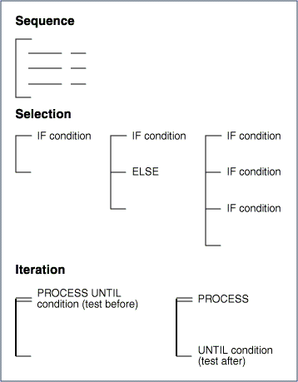

Sample Work Product - Action Diagram: Logic Control

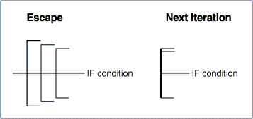

Sample Work Product - Action Diagram: Data Accesses

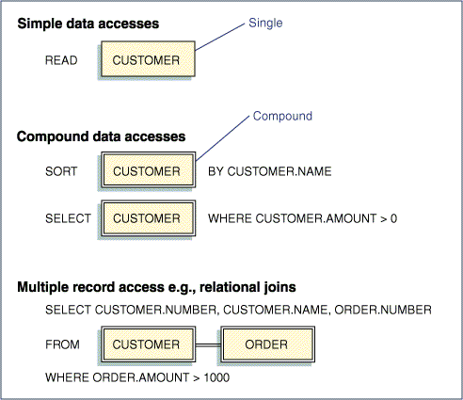

Sample Work Product - Elementary Process Description Verbs

Verb Class | Verb | Definition
Capture | ENTER | Indicates data entry from a screen or from an external source
Data access | CREATE | Populates new occurrences of a record either sequentially or by key
 | DELETE | Deletes an occurrence of a record either sequentially or by key
 | MATCH | Matches the value of the specified data elements to the data elements of a record, to specify the record to be retrieved
 | READ | Reads a record from secondary storage either sequentially or by key
 | SAVE | Stores a record on a non-volatile medium, such as tape or disk for back-up purposes
 | SELECT | Selects a group of records
 | SORT | Sequences the records in ascending or descending order based on the value of a data elements
 | UPDATE | Maintains the values of data elements of an existing record by key
Data manipulation | COMPUTE | Denotes computational activity
Table/string manipulation | EXTRACT | Extracts a value from within a string of data
 | SEARCH | Finds a specific entry within an array
General processing | PROCESS | Transfers control to the named procedure documented as a separate action diagram
Reporting | DISPLAY | Presents an occurrence of an output screen
 | PRINT | Presents an occurrence of an output report
Logic | IF ... ELSE | Permits the selection of alternative processing paths, depending upon whether a binary condition is true or false
 | PROCESS UNTIL | Passes control to a subroutine or in-line common routine (the UNTIL condition is checked before the PROCESS is performed, when placed at the top of the bracket)

Sample Work Product - Program Logic Specification Verbs

Verb Class | Verb | Definition
Capture | ACCEPT | Accepts data from a screen or external source
 | EDIT | Verifies data elements on conditions that do not need to receive external data
 | VALIDATE | Verifies the value of a data element in a record
Data access | CREATE | Populates new occurrences of a record sequentially or by key
 | DELETE | Deletes an occurrence of a record, sequentially or by key
 | LOCATE | Finds a particular record to start a series of sequential accesses from a specified point
 | MATCH | Matches the values of the specified data elements to the data elements of a record to specify the record to be retrieved
 | READ | Reads a record from secondary storage sequentially or by key
 | SAVE | Stores a record on a non-volatile medium, such as tape or disk for back-up purposes
 | SELECT | Selects a group of records
 | SORT | Sequences records in ascending or descending order based on the value of a data elements
 | UPDATE | Maintains the values of data elements of an existing record by key
Data manipulation | ACCUMULATE | Indicates summation, as a counter or running total, such as year-to-date
 | COMPUTE | Denotes computational activity
 | FORMAT | Arranges a record, data element, or print line into a specific format
Table/string manipulation | SEARCH | Finds a specific entry within an array
 | EXTRACT | Extracts a value from within a string of data
General processing | CALL | Passes control to a subprogram. At the end of the subprogram, processing control is returned to the calling program.
 | PROCESS | Transfers control to the named procedure documented as a separate action diagram
Reporting | DISPLAY | Presents an occurrence of an output screen
 | PRINT | Presents an occurrence of an output report
Logic | IF ... ELSE | Permits the selection of alternative processing paths depending upon whether a binary condition is true or false
 | PROCESS UNTIL | Passes control to a subroutine or in-line common routine (the UNTIL clause is at the top of the bracket)

Sample Work Product - Detail Logic Chart Verbs
Verb Class | Verb | Definition
Capture | ACCEPT | Accepts data from a screen or external source
 | EDIT | Verifies data elements on conditions that do not need to receive external data
 | VALIDATE | Verifies the value of a data element in a record
Data access | CREATE (INSERT for SQL) | Populates new occurrences of a record, sequentially or by key
 | DELETE | Deletes an occurrence of a record, sequentially or by key
 | LOCATE | Finds a particular record to start a series of sequential accesses from a specified point
 | MATCH | Matches the values of the specified data elements of a record to specify the record to be retrieved
 | READ | Reads a record from secondary storage, sequentially or by key
 | SAVE | Stores a record on a non-volatile medium, such as tape or disk for back-up purposes
 | SELECT | Selects a group of records
 | SORT | Sequences records in ascending or descending order based on the value of a data elements
 | UPDATE | Maintains the values of data elements of an existing record by key
Data manipulation | ACCUMULATE | Indicates summation, as a counter or running total, such as year-to-date
 | COMPUTE | Denotes computational activity
 | FORMAT | Arranges a record, data element, or print line into a specific format
Table/string manipulation | INITIALISE | Indicates the assignment of a starting value
 | SEARCH | Finds a specific entry within an array
 | EXTRACT | Extracts a value from within a string of data
General processing | CALL | Passes control to a subprogram. At the end of the subprogram processing control is returned to the calling program.
 | PROCESS | Transfers control to the named procedure documented as a separate action diagram
Reporting | DISPLAY | Presents an occurrence of an output screen
 | PRINT | Presents an occurrence of an output report
Logic | IF ... ELSE | Permits the selection of alternative processing paths, depending upon whether a binary condition is true or false.
 | PROCESS UNTIL | Passes control to a subroutine or in-line common routine (the UNTIL condition is checked before the PROCESS is performed when the UNTIL clause is placed at the top of the bracket)

Unit Test Batch/Interface/Data Migration Programs

Overview | Define the test objectives for the unit being tested. The purpose of unit testing is to thoroughly test the individual modules or set of related modules which execute the migration programs. Each objective is to test for a correct response to an event. For example, a unit test objective may be "to test that a migration program transferred account identification data correctly." Unit test objectives may be grouped into test cycles for execution purposes.

Approach | - Define Unit Test Objective  - Prepare a Unit Test Strategy to document the unit test objectives and test cycles  - Develop a Unit Test Plan where all conditions, steps to be executed to test each condition, required unit test data, and expected results of each step are defined  - Establish unit test conditions to address the verification of the following:  - Output conditions (e.g., displays, reports, updates, error messages)  - Program logic paths, including loop control, exception, and/or error processing  - Edit/validation logic within the program, including table look-ups  - Error handling routines  - Processing algorithms  - Module to module interfaces within the program  - Use of program links  - Production of specified output files  - Reading of specified input files  - Control and security conditions  - Command language instructions for the program  - Utilities  Unit test conditions describe the explicit scenarios which must be tested to meet the test objectives.  - Define unit test steps for each test condition  - Prepare Test Data Specifications  - Generate Unit Test Data by developing test data files to enable the execution of all test conditions and steps defined in the unit test plan.  - Define expected results for each test step  - Conduct unit tests until each test has been successfully completed. Actual results are reconciled with the expected results and all program logic errors are corrected. Final test results are attached to the unit test plan for each test condition/step. Successfully conducted unit test plans are reviewed by the team leader.

Work Product | Typical work products are test strategy template, test plan template, test data specification template, unit test plan, data analysis specifications, performance test plan, performance stress test.

Sample Work Product

Similar to Work Products presented in section Unit Test Web Pages.

